Organisational Development and Professional Learning
Toward situational competence in:
Project managing your research degree
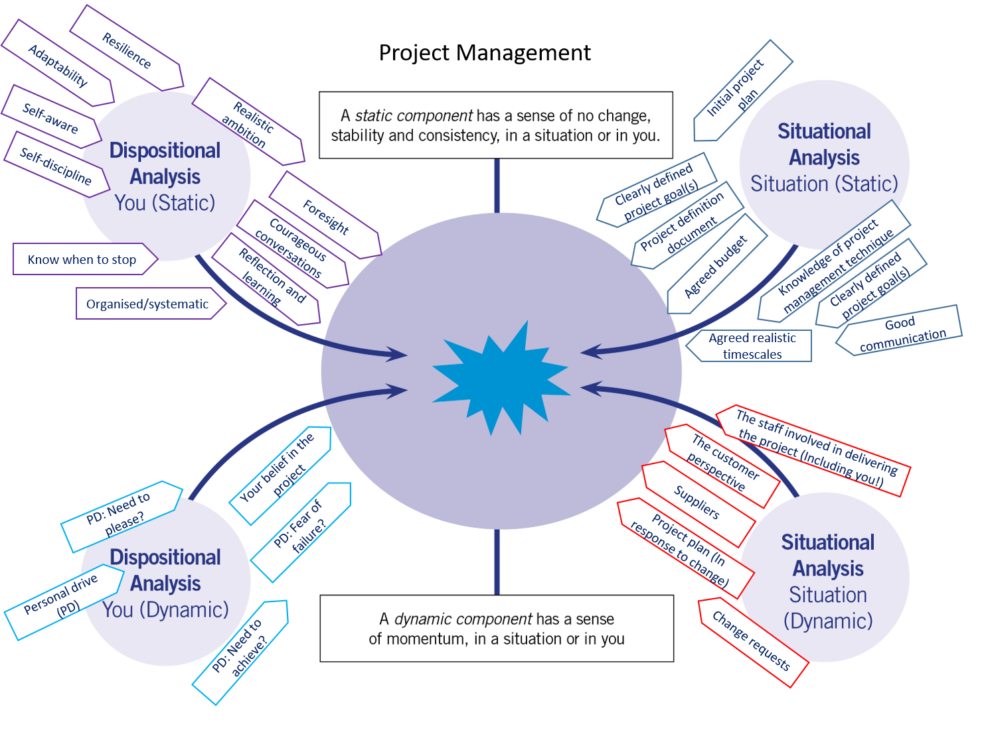
Downloads and video introductions to dynamic development available at:
https://researchersupport.leeds.ac.uk/dynamic-development/downloads-and-video-introductions/

Acknowledgement
This resource has been put together by Dr Tony Bromley of OD&PL. It has been created by the re-writing, adding of additional material and a reframing for the dynamic development context, of a handout that was originally used for a ‘face to face’ project management workshop for many years. The handout evolved over the years through input from the multiple people who provided the workshop at the University of Leeds. I'd like to acknowledge and thank those contributors for their input within the context of, who specifically contributed which part, I'm afraid, having long been lost in the mists of time. However, if you can shed some light, please, do get in touch and I would be happy to amend this acknowledgement t.p.bromley@adm.leeds.ac.uk

Contents
Introduction 4
SECTION A: Situational Awareness 5
Static components (Situational) 5
Step 1: The idea 5
What do you see as the success criteria for your PhD 'project'? 5
What are your 'project' deliverables? 6
Mind-mapping the possibilities 6
Project constraints 6
Step 2: Define tasks 6
Defining tasks - Drilling down 6
Step 3: Consider risks 7
Step 4: Plan 8
Example Gantt chart 8
Other key features 9
Critical pathway 9
Step 5: Implement 9
You 9
Your stakeholders 9
Step 6: Review 10
Dynamic Components (Situational) 11
SECTION B: Dispositional Awareness 13
Aspects of disposition relating to project management to think about 13
Static components (Dispositional) 13
Dynamic components (Dispositional) 14
SECTION C: You in the project management situation, reflection and analysis 15
Your motivation for looking at this project management resource 15
Dispositional developmental questions 16
Step 1: How would you characterise the project management situation now? 16
Step 2: Some questions and thoughts for you 17
Step 3: So to develop my project management competence I'm going to... 17
Step 4: From situational competence to capital... 17
Project definition 19
Resources 20

Introduction

Figure 1: Project management expressed in static and dynamic components. We will be explaining this diagram in the following pages.

There are many ways to manage your research degree. Here we take a project management approach. Project management techniques are utilised across every aspect of working life from manufacturing companies through the service industries and education etc. There are many systems with great depth that you can study and gain qualifications in. If you would like to find out more, with a view to perhaps taking up a project management role in the future, three of the most common project management systems to consider are PRINCE2, Agile and Lean.
However, in this resource we focus specifically on project management ideas that can support you in the organisation and self-management of your research project toward finishing you project in good time ahead of your submission deadline. We also add in here what the project management systems do not, in that we consider your disposition, helping you understand how you might get the most out of the ideas specifically for you. The consideration of both the situation (project management in this case) and disposition is central to the Dynamic Development approach to personal and professional development around which this resource is built, with respective sections. To learn more about Dynamic Development please got to the website https://researchersupport.leeds.ac.uk/dynamic-development/downloads-and-video-introductions/where you will find a guide to download and links to explanatory videos; Part 1: The Flawed concept of skills - Part 2: An overview of the Model - Part 3: ‘Static’ and ‘Dynamic’ components of disposition and situation - Part 4: Situational competence, capital and employment

SECTION A: Situational Awareness
As we have said, in analysing the project management situation it is important to recognise both the static and dynamic components of project management that are 'in play'. It is important to learn and understand project management techniques in order, for example, to create a viable initial project plan (a static component) but it is also important to understand that a plan itself has to evolve in response to change (a plan also becomes a dynamic component).
In this section we look at project management technique providing a simple 6 step process that you can follow.
For 'static' components in this case it is predominantly about having a knowledge of project management technique and making sure you have all the right foundations in place for the project. Such as project plans, agreed timescales, realistic timescales, budget agreement etc. The following sections take you step by step through a project management process.
This section of the resource is structured around this project management life cycle.

Figure 2: A project life cycle.

Static components (Situational)

Step 1: The idea
All projects need clearly defined goals. We need to know what the project is hoping to achieve before we start. What is the point of the project? What is the issue(s) the project is trying to address? How will we know when the project is finished? How will we know the project has been successful?
Next, thinking about your PhD, how would you answer...
What do you see as the success criteria for your PhD 'project'?
(You will of course need to have a thesis that passes, but do you want to publish, attend conferences, teach, present at conference, have a job secured for after your PhD etc...?)
What are your 'project' deliverables?
This is a simple statement of the outputs of the project that follow on from your success criteria. (e.g. A thesis, a conference presentation, and two published articles/papers)
Defining your success criteria will help you prioritise your work. If you are doing something that will not contribute to achieving your success criteria, at least question yourself as to why you are doing it.

Mind-mapping the possibilities
A next stage is to do some free thinking and explore all the possible areas you could cover within your PhD project. Try to keep your mind open and write down as much as you can using the mind-mapping technique. At this point it is important to simply make a note of anything you think of, so as not to disrupt your thoughts. You can make decisions later about what are the priorities. Be aware that you may also need to do this several times, before feeling confident about your mind-map. When you are setting out on your PhD your views will evolve as you read more about your area of work and understand more. Doing the mind-map can also help you clarify new learning and how it all fits in with your project.

Project constraints
Now that you have explored the possibilities within your PhD project you need to consider what project constraints you have. The project has to be realistic within the time frame of your PhD. When you are starting out on a new project it is also not unusual to underestimate how long things take. Conversations with your supervisor will help with this. Note as well that working long hours day after day is most likely to end up being counterproductive. An exhausted researcher can make poor decisions and it is certainly hard to be creative when you are exhausted. Self-care during your PhD is very important. What are the constraints on your project? What commitments do you have outside of your PhD? Will the level of available funding impact upon the research you can do? Look again at your mind map and see if there are things that you would question in terms of whether they are feasible within the constraints that you have.

Step 2: Define tasks

Defining tasks - Drilling down
Now that you have a mind-map of your project you need to start deciding what you now need to actually do to make the project happen. Drilling down or a drill down comes at the next stage of a project when ideas have been generated and possibilities explored. It is about making decisions as to what is realistic and effective.
Drilling down also helps you to see all the tasks that must be completed for the project to be a success. The process breaks the tasks into smaller more manageable ‘packets’ of work, which you can then more easily organise into a structure. The focus is much more on what the individual tasks required are.
So now, turn your ideas about your PhD project into a more structured list of discrete tasks. You need to:
- Consider the constraints
- Consider the success criteria
- Make decisions about what you are going to do that are realistic given the constraints and success criteria

Step 3: Consider risks
We now need to think about any potential risks to the success of the project. We then need to think about anything we can do to reduce or mitigate against the identified risks or adjust the project to remove the risk (provided that doesn't impact against achieving the project priorities).
As a starting point to help you think about risk, are there risks in your project relating to any of the aspects of the figure 3 diagram, which outlines potential sources of risk in general for projects?

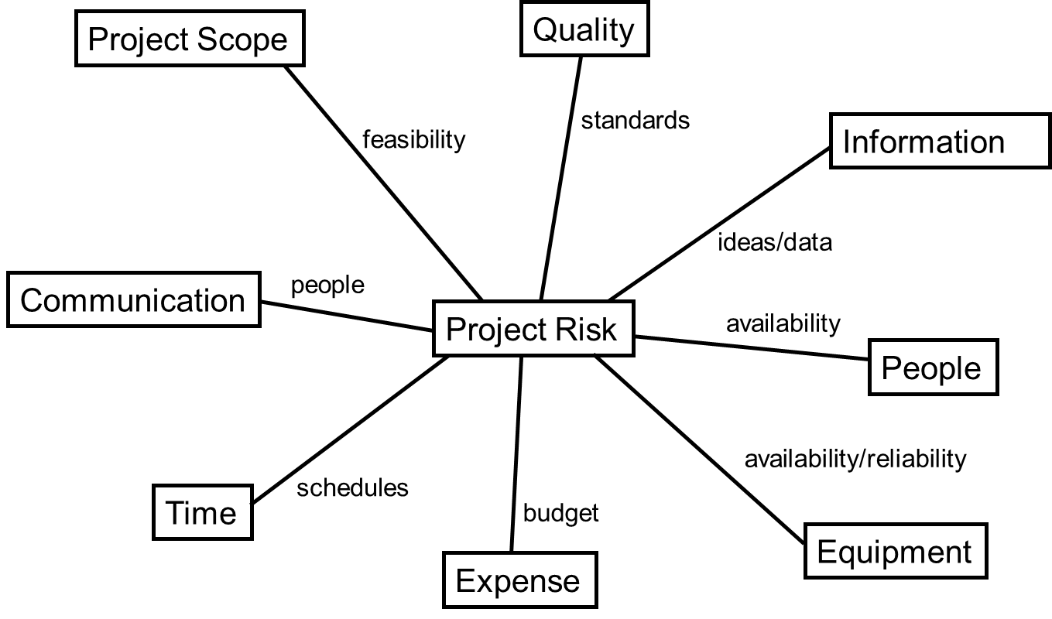
Figure 3: Potential sources of risk in projects.
Once you have identified risks to your project you need to think about how serious they are in terms of threatening the success of your project. Using a 'Risk matrix' such as the one in the diagram below is a good way of thinking about how important a risk is. For each of the risks you have identified in your PhD project how would you rate them using the risk matrix? If you rate any of the risks with a '9', then options you need to think about include:
- If the risk relates to something that is under your control, then make changes to lessen or remove the risk.
- If the risk relates to something not under your control, can you make any changes that would get it under your control?
- If it is high risk and not under your control, can you still achieve your PhD project success criteria without doing it? If yes then don't do it! If you do need to do it then think about how you can reduce the risk as much as possible.
You should of course discuss all this with your supervisor(s)!

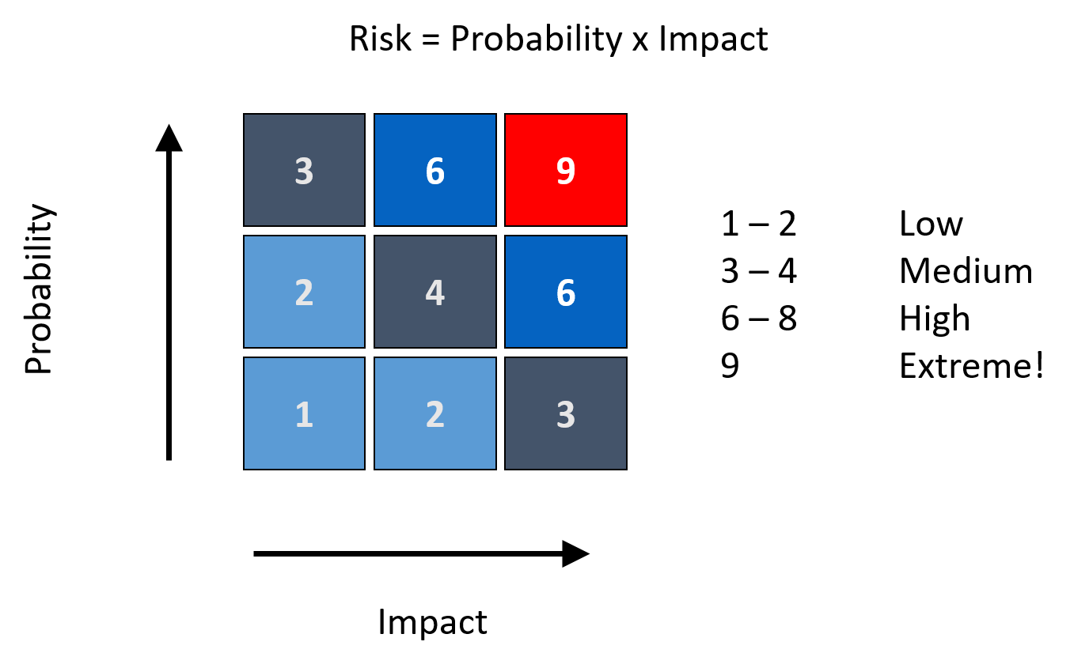

Figure 4: The risk matrix.

Step 4: Plan
By following the steps so far, you should now have a mind map of your project, a list of tasks and have considered risk, adjusting your tasks or mind map as appropriate to reflect the identified risks.
Once you are happy that you have a comprehensive list of tasks or ‘work packages’ for your project you need to start to organise them. Work out which of the tasks need to happen first and how long each will take while building in any contingencies that may have emerged from your risk analysis. The best way to do this is by using a Gantt chart.
Start by listing the activities and allocate duration, to each activity. Then add columns for the time axis. A simplified Gantt chart is provided below and illustrates key points. The Gantt chart provides a visualisation of the project. This way you can see how long the whole project may take and where the important goals and milestones are.
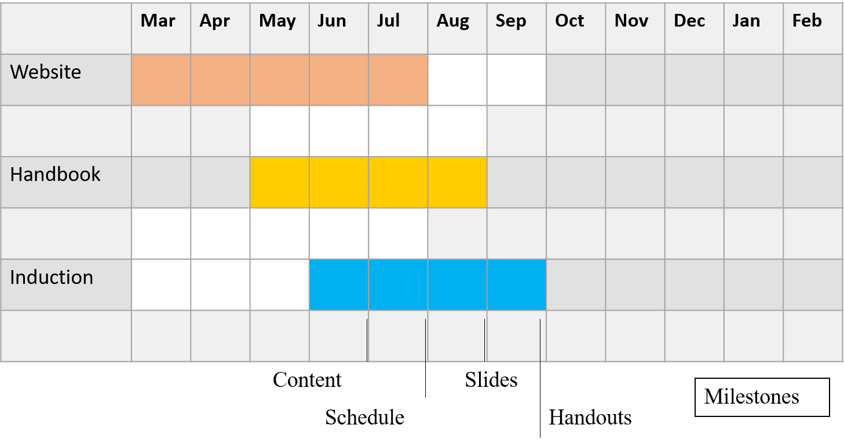

Figure 5: An example Gantt chart for a project to revise and update an induction workshop.

Example Gantt chart
As a simple example for illustration, this is a Gantt chart for a project to revise and update an induction workshop for postgraduate researchers to be delivered in October. There are three main tasks listed in the left-hand column; Website; Handbook; Induction workshop. Each of the three areas require modification ahead of delivery of the new induction workshop in October. In this Gantt chart work on revising and updating information on the website is scheduled to begin in March and be completed by the end of July. Information for revision and updating in the postgraduate researcher handbook is scheduled to start at the beginning of May and be completed by the end of August. Finally, the revised induction workshop will be looked at from the beginning of June until the end of September such that is ready to be delivered as required in October. Within each of the three areas there are likely to be sub-tasks. This is illustrated for the 'Induction' bar on the chart. A number of milestones indicating the sequencing of sub-tasks and when they should be completed are indicated. For this Gantt chart the content for the revised induction workshop should be agreed by the end of June. The tutor schedule/programme for the workshop should be agreed by the end of July. PowerPoint slides for the workshop should be prepared by the end of August and finally the handouts for participants should be written and printed by the end of September.

Other key features
This is a simple example, however, observe that the chart scheduled this way shows all three tasks running concurrently for the months of June and July. When you construct your own Gantt chart look for this aspect and consider if running more than one things at once is realistic. For example, you may have a plan for your research and then find that you would like to present at a conference. If you have a Gantt chart you can better consider if it is realistic to continue with your original research plan and add in an extra 'bar' to cover the work needed to prepare a conference presentation. You may have to adjust your plan and either move a task forwards in time or backwards in time.
Slack - This Gantt chart doesn't schedule any 'slack' in the system. Particularly for the induction workshop task. This is scheduled for completion at the end of September for an October delivery. What happens if anything unforeseen does arise that causes a delay in putting the workshop together? The Gantt chart as scheduled does not allow any flexibility on time. Therefore, perhaps the induction workshop task should be set to start one month earlier and be completed by the end of August. If there are any issues then there is still slack in the system to cater for this, such that the October delivery deadline can still be met.

Critical pathway
Is there a critical pathway through your project i.e. you have to complete a certain task before a next one can be done. For example, simplistically, you can't analyse your data before you have collected it. So what is the critical pathway through your project? Also what is critical to the project success?

Step 5: Implement

You
Making plans happen is much more than writing a good plan. Consider both the dynamic components and disposition awareness sections of this resource to support you in making things happen. Particularly if you have had difficulty in the past in making projects happen. You may understand project management technique very well but perhaps it is one of the dynamic components that you haven't managed well. Or perhaps there is more you can do in terms of your own dispositional development that would help?

Your stakeholders
Managing the people involved with your project can be one of the hardest skills to master and is also one of the most important. Interacting with the right people in the right way can have a big impact on the success of your project. For example if you need to collaborate on a project in order to use some lab equipment, access survey participants or gain access to a particular archive, you need to make sure you know how to go about doing that, so that the people in charge of the resource will help you.
When identifying stakeholders it is essential that you have a name or a specific person within an organisation in mind. Relationship building is important in project management. In your doctoral research, who are your stakeholders? (suggestions are listed below)
- University administration (is it the faculty graduate school manager who usually helps you out?)
- Supervisor(s)
- Funding body
- Collaborators
- Technicians
- Anybody potentially interested in the impact of your work
- Study participants
The stakeholder analysis diagram (Figure 6) can help you consider how important each stakeholder is and how you want to communicate with them.
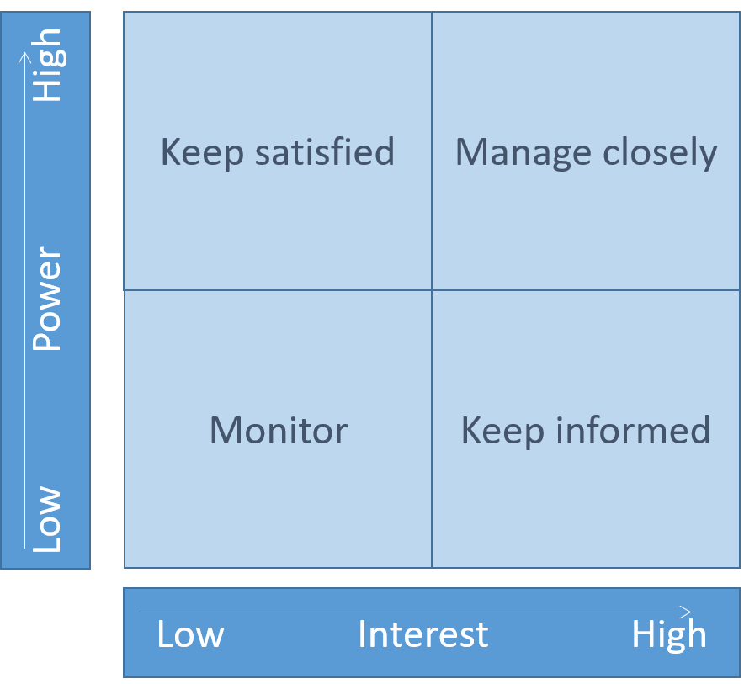
For those you identify as highly influential in your project (high power) and very interested (high interest) make sure you communicate with them regularly!

Figure 6: A stakeholder analysis diagram.

Step 6: Review
This is a short section, but important however. It is always essential to keep reviewing progress in a project and making adjustments to plans and anything else, as necessary along the way, to support the project being successful. A research degree has a definite deadline to it in terms of when it needs to be completed. You need to have a good idea of what progress you are making. The University of Leeds (as with most universities) has a system of transfer and end of year review stages that supports the review process, but also make sure you regularly stop and review your progress against your plans. This could be a simple as looking through plans once every couple of weeks to see what you have achieved, what you need to do next and whether you need to revise the plan based upon new things you have learnt whilst doing the project. Perhaps your initial thoughts on how long something will take was an underestimate?

Dynamic Components (Situational)
Creating a reasonable initial project plan requires a knowledge of project management technique as described in the 'static components' section. However, managing a project to a successful outcome requires both knowledge of technique and an ability to manage the dynamic, changing environment in which the project will exist. This section looks at dynamic elements of a characterisation of the project management situation that are important to recognise and consider in order to be successful.
So far we have analysed the situation of project management in terms of static components. This involves learning basic (or more advanced) principles of project management. However, knowing and understanding these techniques is only part of the challenge of projects being successful. We now need to talk about 'dynamic components'. It is these that can be the greatest challenger to the success of a project. The figure 7, below we have used throughout this resource. It presents an expression of project management in static and dynamic components of situation and disposition. In this section let's focus on the situational dynamic components.
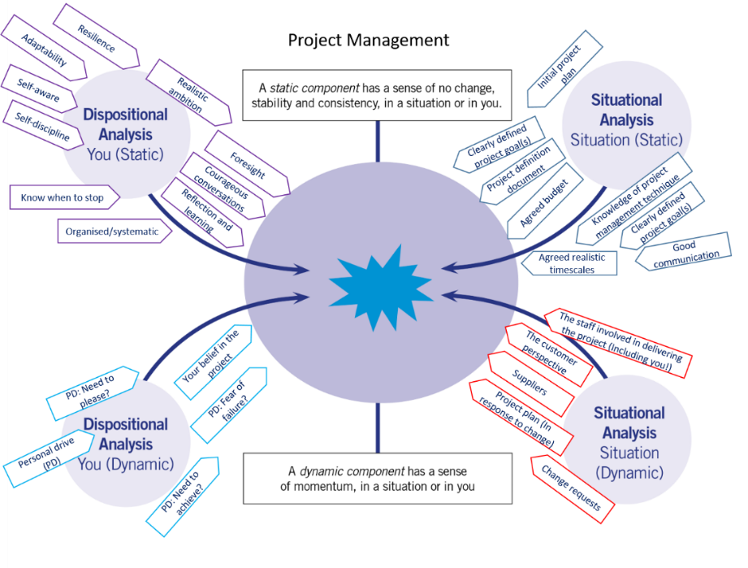

Figure 7 (As Figure 1): Project management expressed in static and dynamic components.
By 'dynamic' remember, we mean factors that seem to have a sense of momentum of their own and that can be difficult to manage. Here are some of the dynamic factors for you to watch out for in project management with a few ideas on how best to manage them:
- The project plan: Yes this might be surprising but the terrific project plan you put together is itself dynamic. You need a plan (a static) but, a plan is always only at best, the best plan you can create at the time you create it. It will and should change as your research project evolves. In the early days of your research you may for example underestimate how long it takes to interview somebody and transcribe their responses. or perhaps an experiment takes a lot longer than you initially thought. Adjusting your plan as you learn more will keep you on track with realistic targets. You may have to compromise!

- Supervisor perspective: In the diagram above we call it 'customer perspective' for generalised purposes. Your supervisor is a customer in a sense. You may set off on an agreed research direction. However, their view might evolve and change. How will you manage that change within your project? If you have a good project plan that can help. A clear Gantt chart (or even a bullet point list) setting out your future intentions with time-scales can be really helpful in discussing change.

- Change requests: We have touched on this in the supervisor paragraph above. It may be your supervisor(s) that requests change to your project. However, who else may request change? Are you sponsored. Might they ask for different things? May you see an opportunity to write, publish or attend a conference? Or what if family or friends present you with a plan you weren't expecting!? All can cause change to the project. Having the plan helps as we have said, but also ensuring you communicate with people regularly, simply asking if all is okay for example can reduce the impact of the dynamic surprises. Another important management tool is to make sure you have 'slack' in your plans. It is almost inevitable that some dynamic change will arrive in your project and you will be thankful for the 'space’ you left in the plan. If you find yourself thinking. for example, If nothing else gets in the way I'll be able to finish this aspect of the research in three months', I’m afraid something will very likely 'get in the way'! That is the dynamic nature of project management in contrast with the static nature of project planning.

- Other people: Finally this is a 'cover all' bullet point for people. People, all of us, you and me, are dynamic. We can misunderstand, we can miss deadlines, we can forget etc... So anywhere where there are people in your project keep the communication going. Just 'check in' now and again.

SECTION B: Dispositional Awareness
In this section we explore the dispositional aspects of project management. The tools and techniques can be learnt, however, it is commonly the application of the ideas at a personal (dispositional) level that is challenging. You may well have already had the experience of excitedly creating a plan and then finding the plan somehow seems to fall apart rapidly as the deadlines you set yourself fly by. We can do something about this...
Project management is an ordered, systematic, disciplined approach to managing projects. Applied to your doctoral project, it means running the project in a self-disciplined way keeping as much as possible to your plans, yet also being adaptable when you need to be, if something changes. However, this kind of approach doesn’t appeal to everybody. There are many ways that you could run your doctoral project. So will project management work for you? The sections here will help you explore your disposition in relation to project management and help you decide if the approach is the way you want to run your project. And please this is just meant to be a guide to traits that can be helpful in project management. There are no 'better' or 'worse' traits or 'right' and 'wrong' traits. We are all different.

Aspects of disposition relating to project management to think about
As author of this resource I have been project managing for about 30 years and teaching project management for nearly 20! So I hope this is coming from some level of knowledge and experience, as I express my view point here of project management dispositional traits that I think are supportive to success in project management:

Static components (Dispositional)
Foresight: can you visualise how a project will unfold? Can you judge the main areas where problems might arise?
Reflection and learning from previous projects: Things go wrong! Its helpful if you can be self-reflective and understand reasons for why something might not have gone to plan such that you can avoid that next time around. Is there somebody you can discuss things with to help you reflect? Make sure you are not too hard on yourself here. Sometimes there is not much we could have done to change an outcome.
Courageous conversations: If you are managing a group of people relating to a project are you able to communicate well generally the needs and objectives of the project? Can you have that difficult or courageous conversation if you feel somebody is not delivering what they should in relation to the project?
Disposition relating to each project life cycle steps: We can't all be brilliant at all aspects of a project life cycle (See the situational awareness section for project life cycle). Do you know the areas you are most comfortable with and also the areas where you'll need help? Are there people who can help you in those areas?
Realistic ambition: There is nothing wrong in general, with ambition. However, if ambition is consistently unrealistic and hence not achieved, it can understandably have an increasingly negative impact on you, the project and all those involved. Can you be ambitious, yet realistic?
Resilience: There are times in projects when they can be 'tough going'. Can you be resilient and keep going in the tough times?
Adaptable to changing environments: The plan will evolve and may need to change. Can you adapt plans and respond to change?
Disciplined: e.g. attitude to personal deadlines: If you give yourself a personal deadline will you hit it or just keep moving it back. Can you be self-motivated to meet deadlines?
Self-aware: Are you communicating the project well? Can you tell if others related to the project are 'with you’? Are you aware of how your behaviour motivates or demotivates people in respect of success in the project?
Organised and systematic: Can you stick to routines of monitoring progress, recording, reporting, checking and reviewing? Can you stick to process, work in a stepwise fashion? Can you label, index categorise?
Know when to stop: Not all projects will work. You will not always be the right person to run a particular project. Are you able to be objective and acknowledge something is not working and that you/the project needs to stop?

Dynamic components (Dispositional)
Personal driver: What drives you? What has it's own sense of momentum within you? Are you driven by a need to achieve or fear of failure? Is the topic of the project personal motivating? Are you driven by a need to sort things out or 'fix' things? Is it a need to please? A need to help? What is the dynamic driver(s) that will keep you going and get the project finished successfully?
Belief: You may find your own belief in the project is dynamic. Some days you believe in the project some days you struggle which leads us to balance...
Balance: If you are for example, driven to achieve (dynamic) can you balance this with, 'I know when to stop and step away' (static)?

SECTION C: You in the project management situation, reflection and analysis
Now let's think about you. Having worked through sections A and B and considered both situation and disposition how can project management work for you?
Following on from the information sections above, we now look to support you in objectively considering yourself in the situation of project managing your research degree, with a view to you understanding what next steps (if any) you would like to take in developing your situational competence in project management. If you are unfamiliar with the Dynamic Development model please read the introductory guide or watch the introductory videos first, before proceeding with this section. The model (figure 8) has three main aspects;
- The static and dynamic development concept used to analyse, reflect and gain understanding (the central hexagon)
- The five outer blue hexagons to support you in finding out more
- The development of ‘Situational Competence’ (as an outcome of 1 and 2).
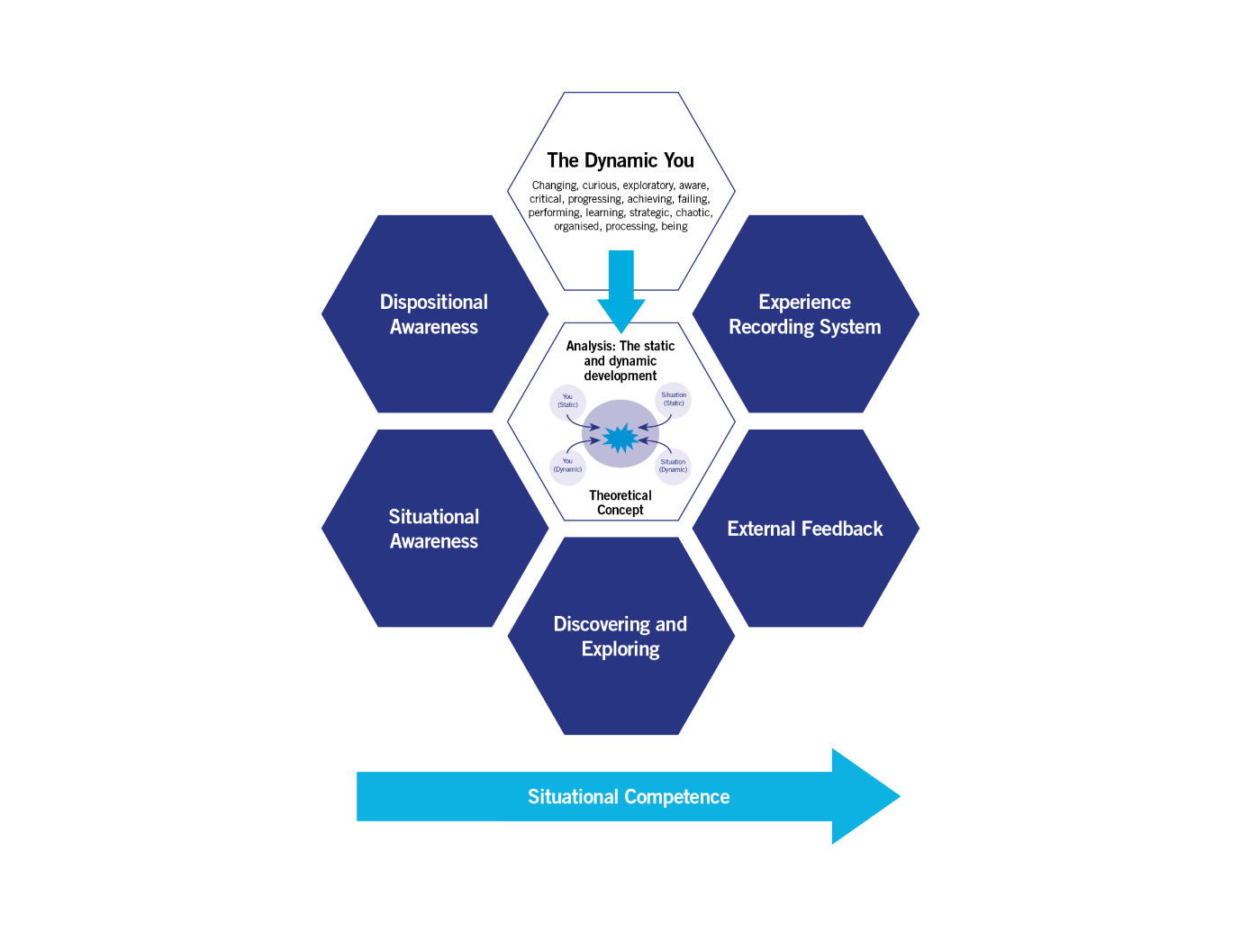

3. What do you want this project management session to solve for you?

Figure 8: The full Dynamic Development Model, showing the static and dynamic concept in the central hexagon.

Your motivation for looking at this project management resource
Below are some questions for you to reflect upon.
- Are there any specific reasons why you decided to look at this resource?
- Do you have any concerns in respective of how you manage your doctoral research?
- As a result, are you looking for this resource to support you in any particular areas of development?
- Has this resource helped you?
- As you have worked through the resource have you made progress even if in just changing your thinking in respect of project management?

Dispositional developmental questions
As you read through this section think about:

- What outcome do your dispositional traits and situational view currently have on the effectiveness of your project management?
- What would you like to change?
- What will you do next?

Step 1: How would you characterise the project management situation now?
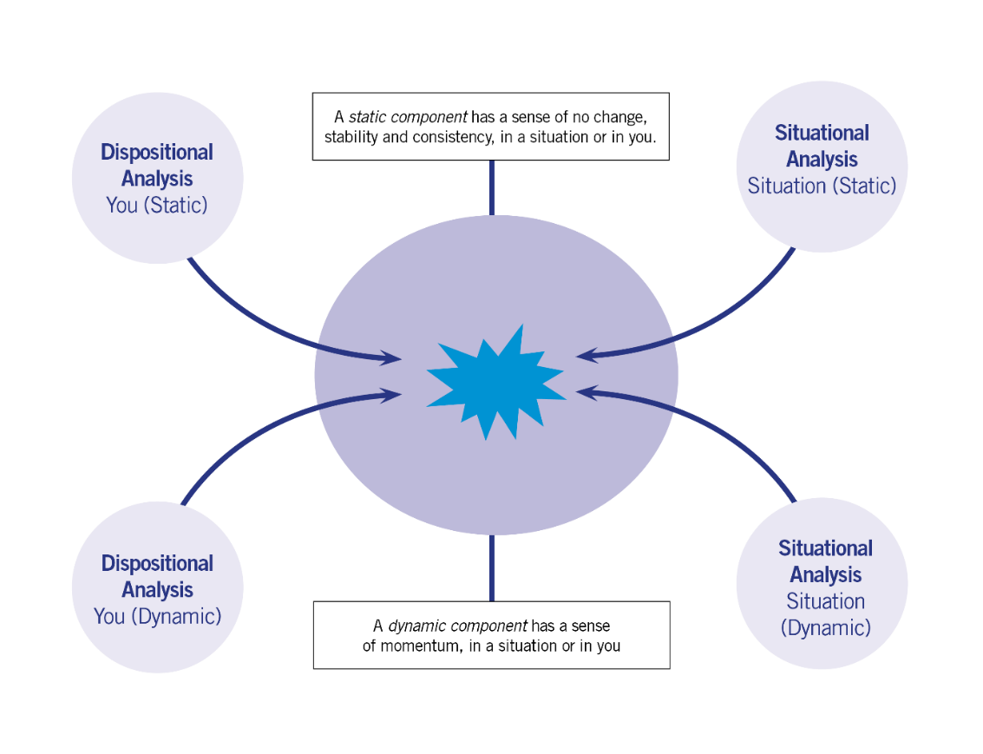
Use the Game Board (below) (download here) to consider the situational and dispositional components of project management as you see them now. If you keep a copy of your initial views you can use the copy as a comparator part of your experience recording. Note, figure 1 has been used as an example Game Board for project management throughout this guide. However, that is my view. You are not me! What do you think?

Figure 9: The blank Game Board

Step 2: Some questions and thoughts for you
In constructing your view of project management in step 1 did you find it easy? Do you feel you are very aware of the situation of project management for you, situationally competent and satisfied that it isn’t an area you need to focus on for further development?
If not, we now need to look at the other five blue outer hexagons in the model to think about what would be the best next steps for you…
- You may need to gain further situational awareness by talking with colleagues about their views and experiences on project management or taking a look at project management courses.
- You may need to gain further dispositional awareness. Have you asked a colleague about what they think of how you manage your research. This will give you objective feedback (external feedback)?
- Have you compared your own progress in project managing your research(experience recording)? At a simple level do you feel more organised this month compared to last month? Is your Gantt chart more realistic and are you meeting the deadlines and milestones you set yourself?
- Discovering and exploring – Do you want to know more about project management to help you with your research degree? Are you interested in exploring project management as a career or for use in other contexts than a research degree?

Step 3: So to develop my project management competence I'm going to...
A simple task for you. Now that you have worked through this resource, gained some feedback, reflected upon it, discussed it etc., write down somewhere what you want to try and do next in respect of developing your situational competence in project management.
Remember, people can sometimes be over ambitious in trying to improve rapidly by changing too much at once. Make sure your target improvement steps are realistic and manageable for you.

Step 4: From situational competence to capital...
I’m sure you will now be building your situational competence in project management.

Now we can look at the last aspect of the dynamic development model and consider what you have built in terms of capital through building your situational competence. (The concept of ‘capital is explained further in Section C page 15 of the Dynamic Development Introductory Guide at https://www.sdduonline.leeds.ac.uk/dynamic-development/)

Table 1 as an illustration, suggests possible capital you may have developed in an example for the situation of academic writing in the three areas ‘Expertise’, ‘Operational’ and ‘Social’. Table 2 offers a blank space (Download the table as a word file) for you to record your own view for the situation of project management using the writing example as a guide. Keep adding to your personal table as you build your situational competencies and build your capital!

Expertise Capital |  | Operational Capital |  | Social Capital
Capital | Field(s) applicable | Capital | Field(s) applicable | Capital | Field(s) applicable
Writing and publishing an academic paper or article | The writing process is applicable to other types of writing. E.g. mapping out content, editing and reviewing, iterations of drafts. | Understanding how the publication process works in the academic context: peer review, journal ratings, open access publication etc. | Academic research  Academic publishing  Academic library roles | Meet journal editors and publishers | Academic research  Academic publishing  Copy editing

Table 1: Suggests possible capital you may have developed in the situation of academic writing for the three areas ‘Expertise’, ‘Operational’ and ‘Social’.

Expertise Capital |  | Operational Capital |  | Social Capital
Capital | Field(s) applicable | Capital | Field(s) applicable | Capital | Field(s) applicable

Table 2: A blank table for you to use to add your own capital. Download the table at https://www.sdduonline.leeds.ac.uk/dynamic-development/downloads/

If you would like to learn more about project management systems with perhaps a view to project management as a career, three of the most commonly used project management systems to look into are PRINCE2, Agile and Lean.
The University of Leeds also has a project management approach which is detailed on the 'Delivering Results' website. https://deliveringresults.leeds.ac.uk/
This includes what is described as a 'lighter' approach. So if you are interested in Project Management Light take a look!
And finally... The Project Definition Document
If you work through this resource you should be able to then complete the Project Definition document. Every project needs a project definition document that simply sets out the purpose and key outcomes of the project. The document is useful for clarity but also to help you prioritise. Ask yourself if the task you are doing will contribute to the project priorities. If not? Ask yourself, 'Why am I doing this?'

Project definition

Project title:

The goal/purpose of the project is…

The benefits of this project are…

Project start date: Project end date:

Maximum allowable overrun Average time allocation/week

Project milestones

Project deliverables

Project constraints (This project will allow time in my life for…)

Resources
A Practical Guide to Delivering Results, University of Leeds, http://deliveringresults.leeds.ac.uk/ (accessed 19/02/20)
Lock, D., Project Management, Gower, 8th edition, 2003, ISBN 0-566-08551-8
Kerzner, H., Project management: case studies, John Wiley & Sons, 4th edition, 2013, ISBN: 1118433580 and 7 others,

