Organisational Development and Professional Learning
for postgraduate research

Toward situational competence in:
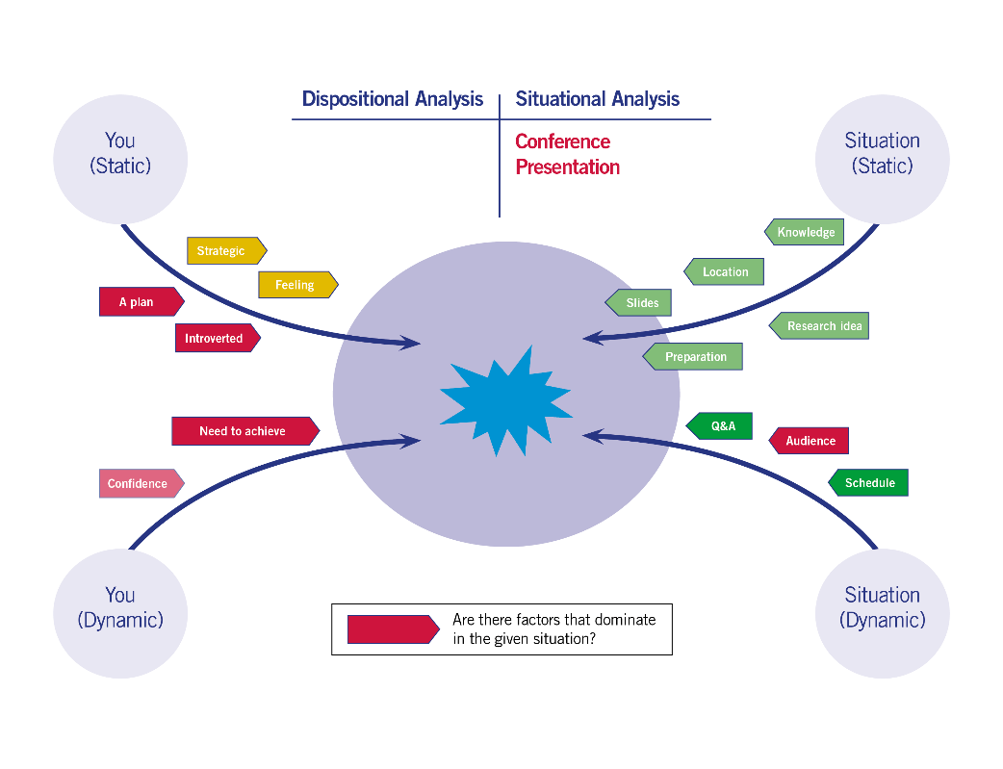
Giving effective seminar and conference presentations

‘Have something to say and say it well’

DOWNLOAD as a word file : https://researchersupport.leeds.ac.uk/dynamic-development/downloads-and-video-introductions/
Also an online resource in the Leeds Doctoral College Organisation on Minerva where it includes imbedded videos from LinkedIn learning.

Acknowledgement
This resource has been put together by Dr Tony Bromley of OD&PL. It has been created by the re-writing, adding of additional material and a reframing for the dynamic development context, of a handout that was originally used for a face to face presentations workshop for many years. The handout evolved over the years through input from the multiple people who provided the workshop at the University of Leeds. I'd like to acknowledge and thank those contributors for their input within the context of, who specifically contributed which part, I'm afraid, having long been lost in the mists of time. However, if you can shed some light, please, do get in touch and I would be happy to amend this acknowledgement t.p.bromley@adm.leeds.ac.uk

Attribution-NonCommercial-NoDerivs
CC BY-NC-ND
https://creativecommons.org/licenses/
Toward situational competence in: giving effective seminar and conference presentations
Contents
Introduction 4
SECTION A: SITUATIONAL AWARENESS 5
A.1.0 Your presentation content 5
A.2.0 What is ‘known’ about the presentation situation? 6
A.3.0 Presentation Structure and Slides 7
A.3.1 Types of presentation 7
A.3.2 ‘Classical’ presentation in more detail 9
A.3.3 Comparing a classical approach with a problem centred approach 15
A.3.4 Further slide examples 16
A.4.0. Presenting without slides 20
A.4.1 Language style 20
A.4.2 Emphasis 21
A.4.3 Anecdotes/asides 21
A.4. 4 Structure 21
A.4.5 Presenting from notes 21
A.4.6 You 21
A.4.0 Additional preparations before presentation 22
A.4.1 Know the Audience 22
A.4.2 Room visit 22
A.4.3 PowerPoint Shortcut Keys 23
SECTION B: DISPOSITIONAL AWARENESS 24
B.1.0 Performance 24
B.2.0 Nerves/Stress 25
B.3.0 Questions and Answers 26
SECTION C: SUMMARY CHECKLISTS 27
Presentation Checklists 27
Checklist 1 27
Checklist 2 28
Checklist 3 30
Checklist 4 31
SECTION D: EVALUATION 32
Presentation Evaluation Example 1 33
Presentation Evaluation Example 2 34
Presentation experience 35
SECTION E: YOU IN THE PRESENTATION SITUATION; REFLECTION AND ANALYSIS 36
Step 1: How would you characterise presentation now? 37
Step 2: Some questions and thoughts for you 38
Step 3: So, next time I present I will… 38
Step 4: From situational competence to capital… 39

Introduction

This guide is one of a series of guides targeted at building situational competence in their respective topic area. Each set of guides is split in to three sections around the following nine questions. Keep the questions in mind as you read through the guides. Be sure also to read the ‘Dynamic Development: Introductory guide’ which explains this new approach to the personal and professional development of researchers, particularly the framing around the consideration of situational and dispositional awareness.
Section A: Situational awareness:
- How is the situation viewed by others?
- How do you view the situation?
Section B: Dispositional Awareness:
- What dispositional traits do others see as important in the situation?
- What dispositional traits do you see as important in the situation?
- What dispositional traits do others see in you in this situation?
- What dispositional traits do you see in you in this situation?
Section E: Analysis
- What outcome do your dispositional traits and situational view currently have on the effectiveness of your presentation?
- What would you like to change?
- What will you do next?
Please visit the Dynamic Development website for more information, downloads and video introductions to the approach:
https://researchersupport.leeds.ac.uk/dynamic-development/downloads-and-video-introductions/

SECTION A: SITUATIONAL AWARENESS

How is the situation viewed by others? How do you view the situation? In this section we provide a wide range of ideas commonly expressed as supportive of effective presentations. We also cover the different styles of presentation that occur across the disciplines. In general terms science and engineering disciplines rely heavily on presenting with projected slides whereas a number of arts and humanities disciplines read out pre-prepared texts. It is important, in terms of situational awareness, to talk with people in your discipline area to understand what is the most common way of presenting.

A.1.0 Your presentation content

A first and fundamental situational point of understanding in respect of delivering an effective seminar or conference presentation is, ‘Do you have something to say that will be of interest to your prospective seminar or conference audience?’ If you have nothing to say it doesn’t matter how well you present, it is unlikely to be a great presentation. Before moving on to anything else in this guide put some thought into what you are going to say.
So, what do you have to say? What is interesting about your work? What is original? What is important about your research? Does it fit with the context and themes of your target conference or seminar?
In summary, what are the three most important things you want an audience to remember about your work? Write these things down in the boxes below:
If you are unsure how to answer this question, give yourself 30 seconds to answer the question spontaneously with no preparation. Record the thirty seconds that you speak. Then play it back and see what you said! Does it sound about right?
1.
2.
3.

You hopefully now have some content. The next question is, ‘Why are you presenting this orally?’ For example, you can obviously always write an academic paper or article about your research for publication. Are you presenting to…
- Test out some new ideas and see what feedback you get?
- To be able to expose your work to a large audience in your field and get the work more widely known?
- To see what questions you get and get practice in responding to them as part of practice in receiving and answering questions about your work ahead of a PhD Viva?
- Any other of many potential reasons...
Understanding why you are orally presenting and specifically what the conference situation can give you that a published written article can not, will help you focus your presentation preparations to a particular purpose(s).
As a final question for this section, ‘What do you want to happen after your presentation?’. Would you like people to come up to you and talk about your presentation in the conference coffee breaks? If yes then you can say in your presentation that you would welcome people catching up with you in the coffee break. Is your research on a website, so people can internet search and find you after the conference? Again, in the presentation you can say that if people want to know more it is online on ‘my website’ or the ‘research group website’. Take the opportunity to make research connections!

A.2.0 What is ‘known’ about the presentation situation?

There are a large volume of texts published that provide advice on presenting. Much of the basic ideas are generalisable and indeed the University of Leeds Library online resource is well worth viewing for an overview of the generalisable ideas. In future sections of this guide we consider a number of these general points in more detail within the situational context of effective research conference or seminar presentation. However, for this section we examined the research literature for published studies that have specifically looked at researchers in the situation of oral presentation of research. It is interesting that the published literature in respect of the specific situational context of ‘effective research conference presentation’ is very limited.

Ohnishi and Ford, (2015) showed how existing doctoral researcher seminar programmes can used as an active training programme to improve presentation skills. They carried out an extensive case study with 95 doctoral researchers presenting in seminars over a six year period. A key finding of the study relates to those presenting for whom English was not their native language. International researchers were rated more highly compared with Australian researchers in their first presentations, however Australian researchers where then rated more highly when delivering their subsequent second and later presentations.

Austin and Kiley, (1996) report on, ‘…a compulsory program of activities called the "Structured Program" that is undertaken during the first 6-12 months of a Ph.D. student's candidature.’ In addition to research topics the programme included, ‘Skills needed to write and publish research papers and theses in the discipline’ and ‘Techniques for effective seminar presentation and participation’. Austin and Kiley, (1996) report a case study of the programme in one department where an evaluation survey of participants and staff was carried out. In respect of skills development students reported a ‘highlight’ as, ‘the opportunity to develop communication and presentation Skills’ and staff reported, ‘The opportunity for students to develop skills in paper presentations for conferences was considered very important’

Copeman, (2015) presents the outcomes of a three year study on the ‘Three Minute Thesis’ (3MT) presentation approach to communicating research to a non-specialist audience. A series of workshops were held with predominantly doctoral researchers who were entering 3MT competitions. Theory and practice from the literary and performing arts was drawn upon in presenting a model of three ‘acts’ for a 3MT narrative, the set up, the struggle and the resolution. Parallels were made with business scenarios, for example an entrepreneur pitching for funding from investors. In the 3MT communication style the particular difference of presenting research with an emotional investment aspect was noted with the need to, ‘synthesise emotionally connected storytelling with traditional academic thinking and writing conventions of detached, dispassionate, reasoned argument based on quantifiable evidence’. In conclusion researchers appreciated:

- being forced to distil and crystallise the essence of their research;
- learning a new way of thinking about the world and explaining their part in it; and
- gaining valuable transferable skills in communication and public speaking.

Adams (2004) reports on a case study, ‘which compared the influence of observing a seminar performance of a peer to that of a senior academic on the confidence, or self-efficacy, for seminar presentations of participants’. Adams found that a peer support model is more effective in enhancing confidence for researchers than the observation of an ‘expert model’.

Stracke and Kumar (2014) also report on the use of peer support groups in relation to presentations skills. They quote a participant, ‘NZ4 found the feedback from peers to be invaluable in improving her research and presentation skills’

A.3.0 Presentation Structure and Slides
Presentation slides and the structure of those slides can be considered as a ‘static component’ of the presentation situation. There are some standard presentation types from which can flow a standard set of slides.

A.3.1 Types of presentation
There are several types of structure that are commonly found in presentations:

Classical
For example a structure such as:

- Introduction
a
b
c
2.a
3.a
b
4.a
b
c
5. Conclusion

It is fairly easy to organise material in this way, but unless care is taken to signal moves from one section to another then the structure may not be apparent to the audience. There may also be a tendency simply to pile fact upon fact. The classical structure does not itself give any strong sense of direction, this must be made explicit by the presenter.

Sequential
Introduction
1 leads to…
2 leads to…
3 leads to…
Conclusion

This looks easy, but the audience must be able to follow all the steps, if they miss one then they’ve lost the flow of the argument. The key points sometimes get lost in the elaboration and so the structure is lost.
Comparative
Introduction: Items X and Y
Feature 1 – X and Y
Feature 2 – X and Y
Feature 3 – X and Y
Summary

This is a demanding method, both for the presenter and for the audience. There is considerable potential for confusion. It requires clear signals of which feature and which item are being examined.

Problem Centred
Statement of Problem
Possible Solution 1 a, b and c
Possible Solution 2 a, b and c
Possible Solution 3 a, b and c
Comment
This may mirror the subject’s own approach. It needs a clear statement of the problem and it sometimes suffers from confusing cross-references between the solutions
FourMat

2 sentences of WHAT
¼ Why
Sell the presentation?
¼ What
What do you do?
¼ How
How does it work?
¼ “Who”
How might we use it?

A.3.2 ‘Classical’ presentation in more detail
The classical approach can also be referred to as ‘Tell them what you are going to tell them, tell them and then tell them what you have told them’ The presentation example detailed in the following pages uses the University of Leeds template available at https://comms.leeds.ac.uk/templates-to-download/powerpoints/ The topic covered is an overview of a method for evaluating the impact of training and development activity. The presentation is not put forward here as a ‘perfect’ presentation but is used to illustrate a number of presentation ‘tips’.

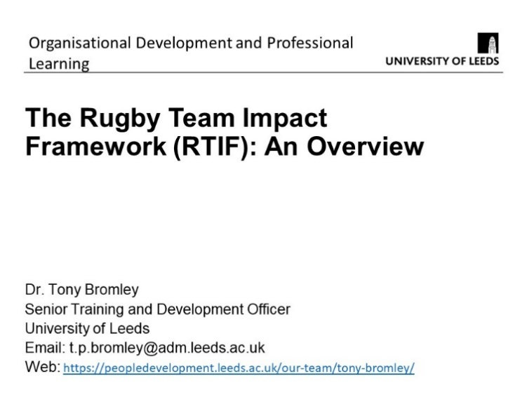
Slide 1: Simple bold title
Clear contact details
How can people get in touch with you?
Mention verbally you are happy for people to contact you
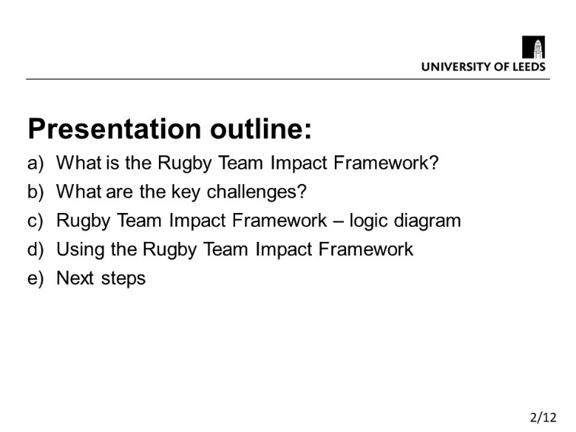
Slide 2: Simple list of what you will cover in the presentation
Slides are numbered so that the audience can see where you are up to and how many slides are left
Heading style is set here and should be consistent throughout the presentation. Same font, same size and bold. Same position on the slide
The style of text below the title is also set from here and should be consistent in the presentation
Refer back to this outline as you go through the presentation so the audience know where they are.
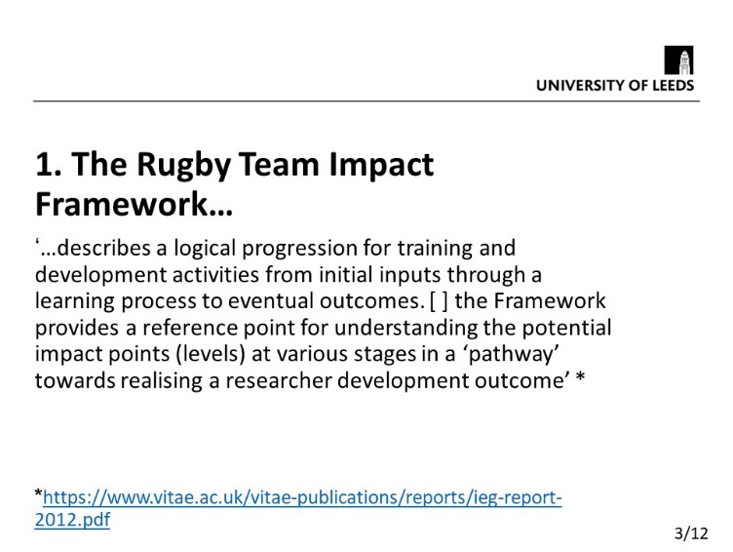
Slide 3: This is a clear concise statement of what the subject of the presentation is and it is placed right at the start.

Details of how to obtain further information are also given for the first time by referencing the source of the quote. They are also included on the final slide. This can also be mentioned verbally. Unlike an academic paper the full reference is not given merely a link to where it can be found. This saves space and keeps clarity and simplicity in the presenttion

The title is numbered and is exactly the same as it is stated on the previous outline slide for consitency and ease of following the presentation
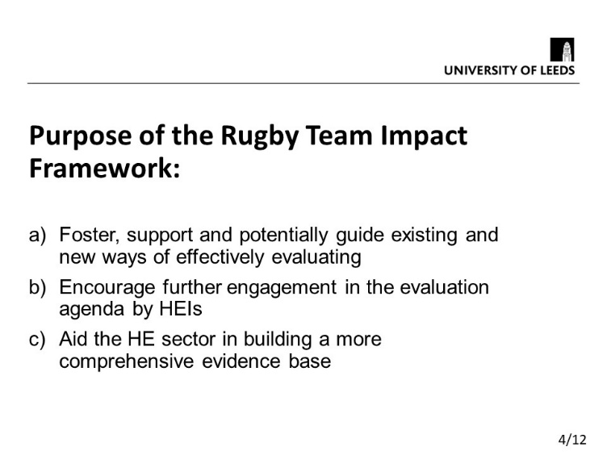
Slide 4: A clear statement of purpose. What is the point of the work? What are you trying to achieve? Simple sentences, not many words!
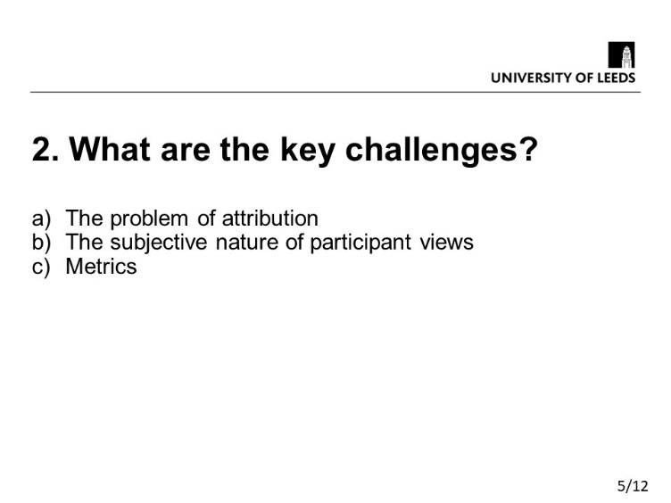
Slide 5: This is the second title from the presentation outline given previously (Slide 2). It is exactly the same number and text for ease of reference. It is a useful technique in presenting to pause occassinally and recap. In this presentation you could pause here. A recap would state, ‘We have covered what the framework is, what it’s purpose is and what the key challenges are, now lets have a look at the framework itself…’ next slide…
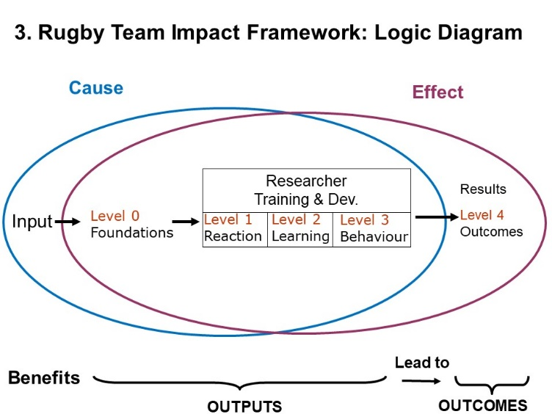
Slide 6: Complicated diagrams should be avoided! This is because they can be too difficult to grasp and understand in the context of the short time available in presentation. The diagram on this slide is very close to being a diagram that should be avoided! However, it has bold large text and is actually simplified from the published version. You can also hand out a copy of the diagram to an audience. Go through the diagram clearly pointing out features when you present it. Again the title of the slide is the one given in the presentation slide. Note when using colour to differentiate between two things (in this case ‘cause’ and ‘effect’) avoid red and green as this is the most common form of colour blindness
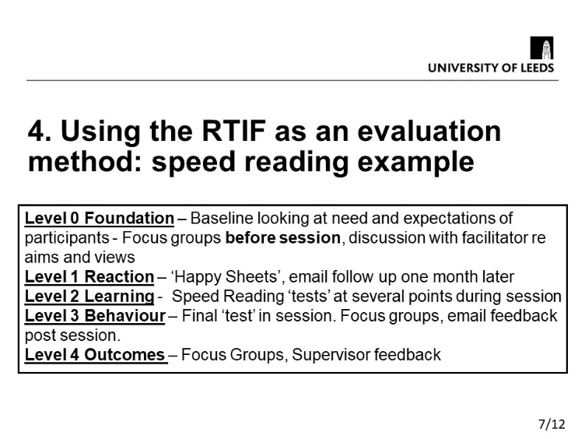
Slide 7: In this slide there is a lot of text. It would be normal to break this up in to two slides. However, in this instance it has been left as one slide such that the process covering all levels 0 - 4 can be seen in one slide for clarity.
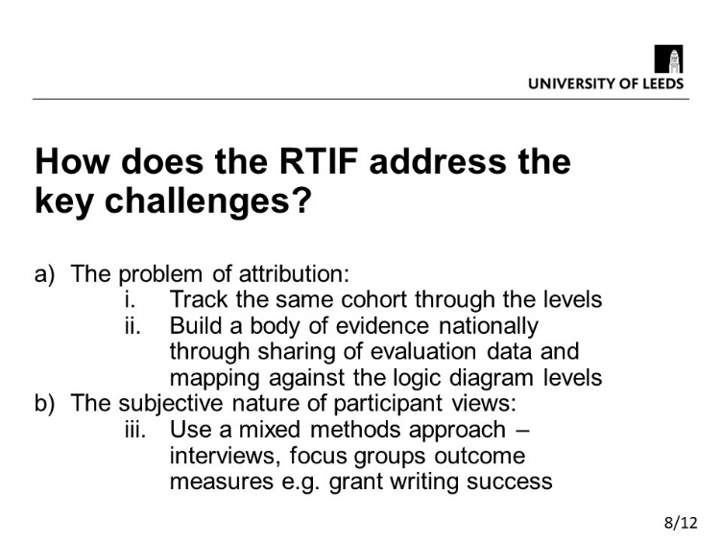
Slide 8: This slides links ideas together set out earlier in the presentation. In slide 5 the key challenges were stated. This slide states how the challenges have been met. So in this presentation questions are raised and then clearly answered later in the presentation.

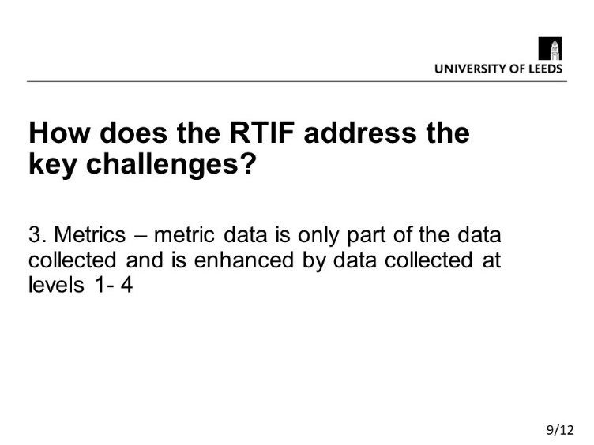
Slide 9: This slide provides the final point in respect of how the key challenges were met.
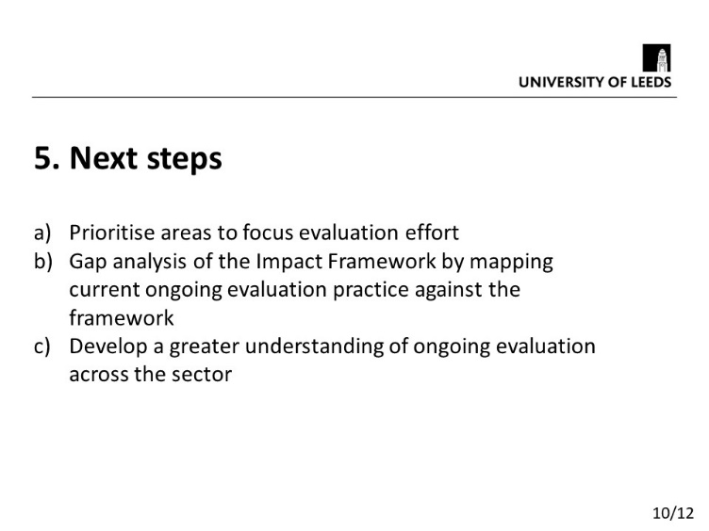
Slide 10: Next steps:This is were as a presenter you can suggest the areas of development and potentially start some contacts with the audience. Be open. Let the audience know you’d be happy to talk about the next steps and work with people. Let the audience know you are interested in their views on your work
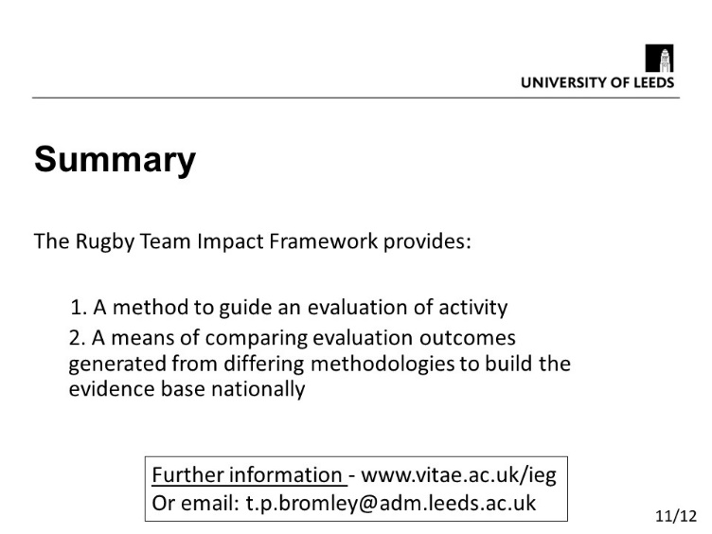
Slide 11: Finally – What do you want the audience to remember about your presentation above all else? Put it here! With your contact details!
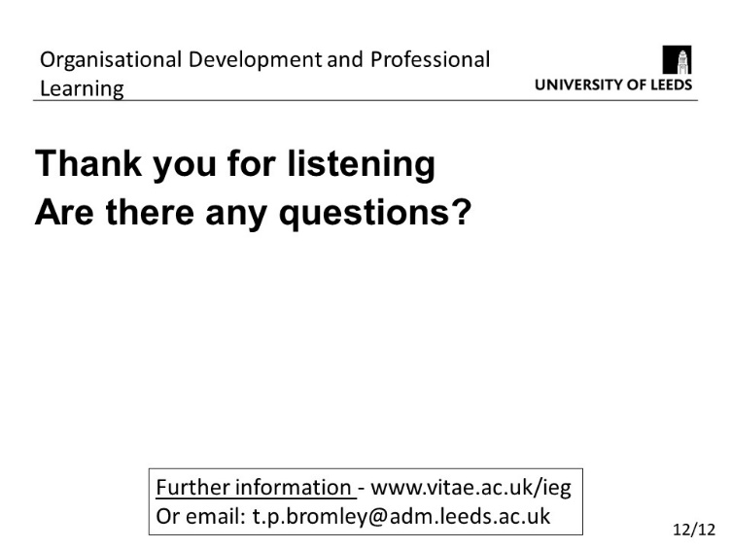
Slide 12: Thank the audience for listening. Flick back to slide 11 after thanking the audience so that your summary slide is on the screen during any questions. Hopefully there is more chance of the audience remembering it

The presentation above has 12 slides which is possibly too many for a ten minute presentation, particularly given that slide 6 has a complex diagram that may need some explanation. Approximately one slide a minute appears to work well as a starting point but then consider how much time you will need with each slide and adjust the number of slides appropriately. Also have an idea of what slide you could leave out if it is clear you are going to run out of time.

A.3.3 Comparing a classical approach with a problem centred approach
Below are slides taken from two presentations introducing a new framework for evaluating the impact of the training and development of postgraduate researchers. The presentation material is the same but two alternative approaches to the opening slides are provided.

Classical presentation of information | Problem centred ‘framing’
 | 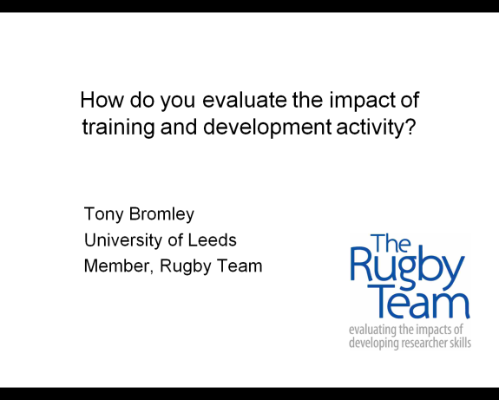
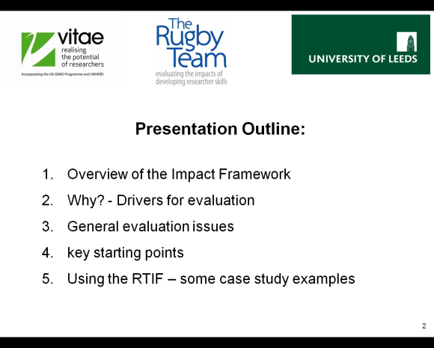 | 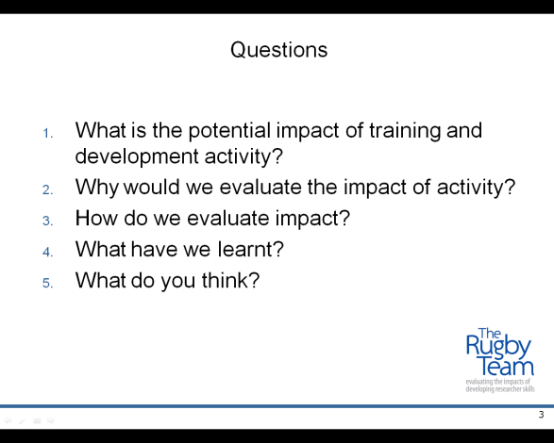

A.3.4 Further slide examples

The following are a range of slides illustrating various approaches that may spark some ideas for your own presentations or point out things to avoid. For advice on colour schemes see http://www.colorhexa.com/
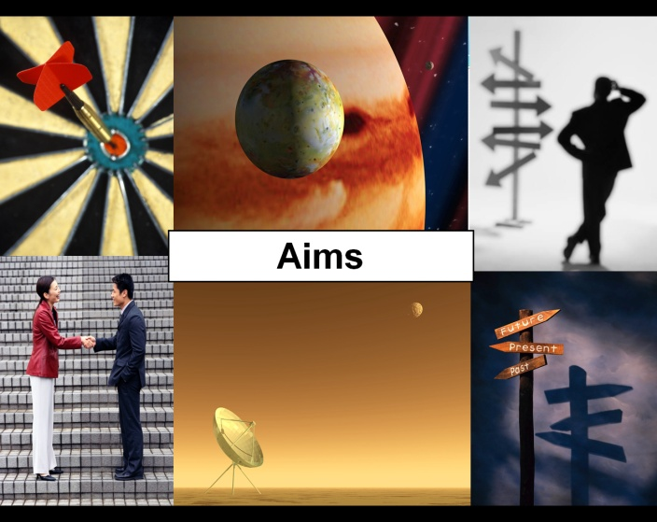 | This presentation approach uses a number of images and minimises text. Another option is to use a single image and no text. The presenter provides the detail based around the image. The image must be chosen carefully such that it makes the point required quickly and is memorable
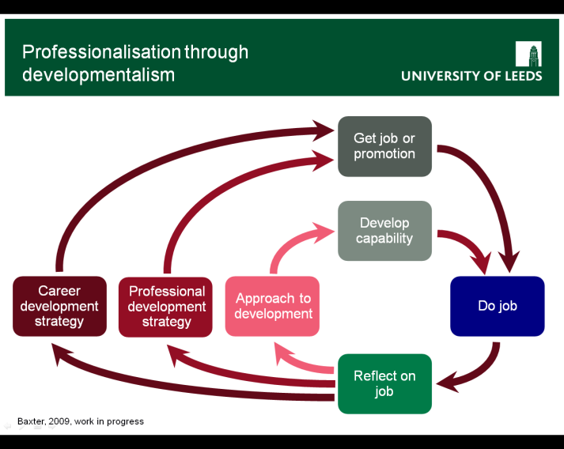 | Difficult or complex concepts can be expressed effectively in diagramattic form. The diagram should be simple, use bold text and can be revealed step by step as it is discussed in the presentation. Allow time for this in the presentation. You are likely to spend signficantly more time describing a diagram than a simple bullet point list of text.
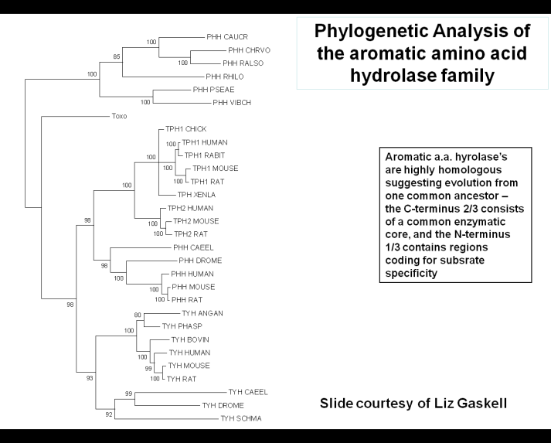 | Slide 1/5 it may be necessary to show content such as that in this slide which when displayed is very difficult for an audience to read. However the next sequence of slides highlights each important area so that it is understandable for the audience
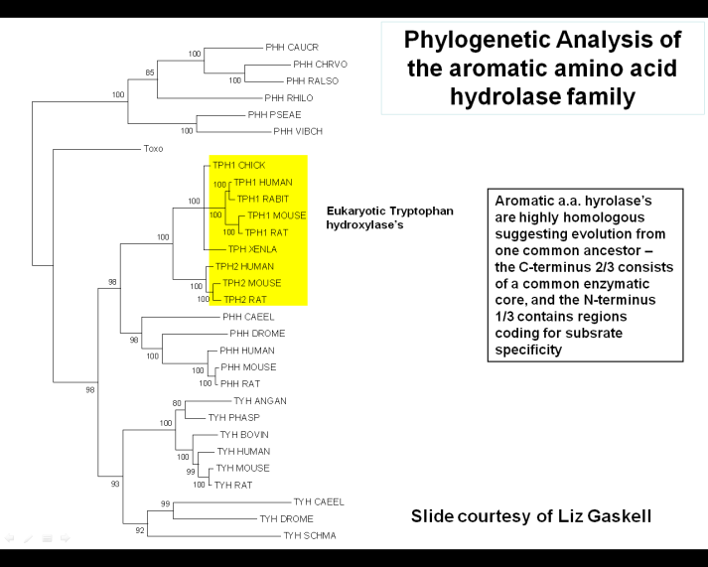 | Slide 2/5
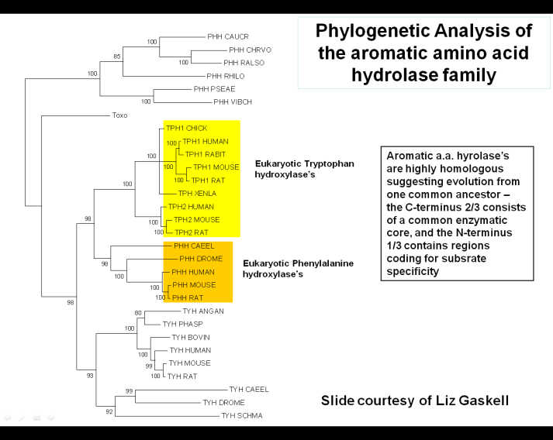 | Slide 3/5
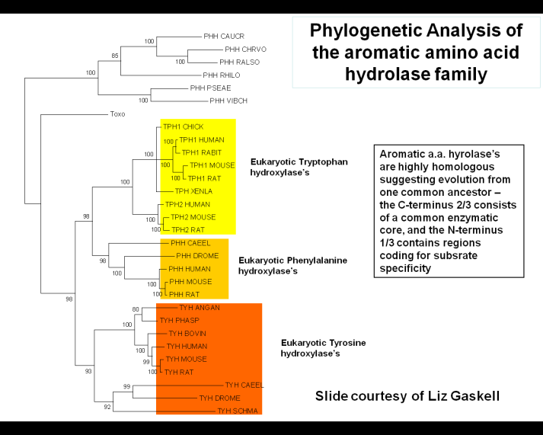 | Slide 4/5
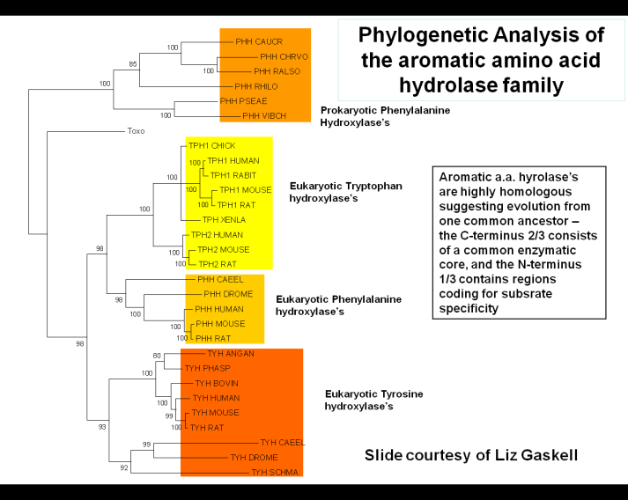 | Slide 5/5
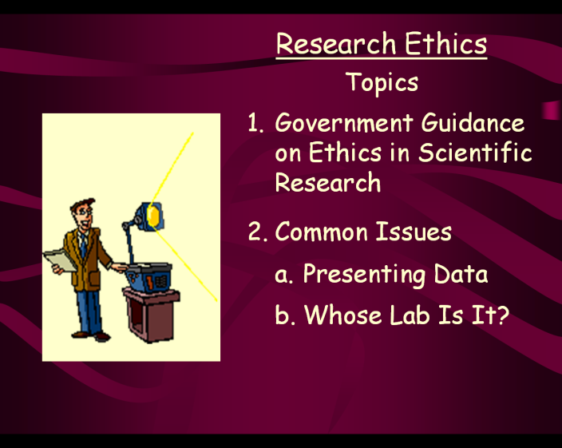 | Clip art: There have been many presentation workshops at the University of Leeds over the years. When we ask participants whether they like clip art the majority say no.  Coloured slide background: Again when we ask, the majority say they prefer black text on a white background.  Animation: most people appear to prefer only very limited animation in presentations. The animation must be there to add something to the visualisation and not there ‘just because you can’ !
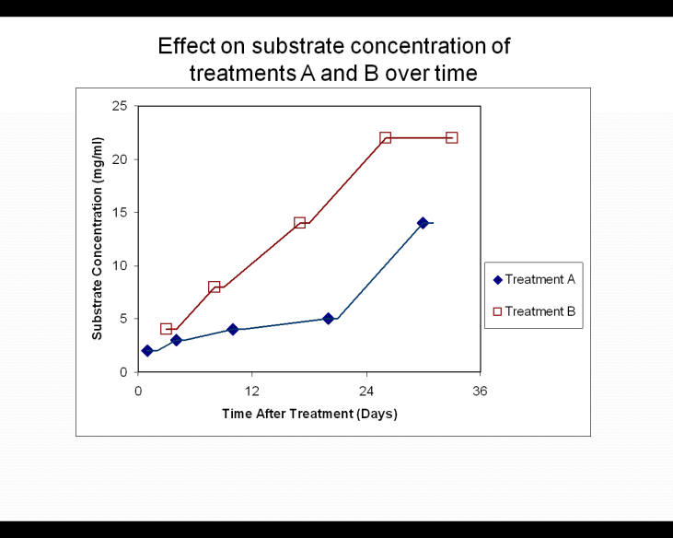 | Any graphs should be bold and clear for presentation. The graph will usually have to be adapted from something you might have used in printed form. Make sure the axes titles and numbers are in a large font so they can be easily read. You can use an orignal graph that you might use in a paper and then over lay bold axes and numbers whilst describing the graph to the audience.
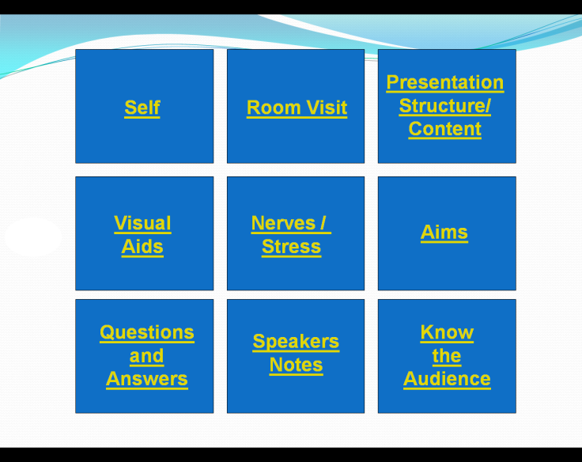 | Hyperlinks – This slide allows you do the presentation in any order. For example, the audience could choose their particular interests. Each heading is hyperlinked to the required place in the presentation for that topic. Also every slide in the presentation has a hyperlink in the bottom corner which when clicked will return you to this ‘menu’ slide. This type of slide could also be displayed at the end of a presentation with each heading representing a section of the presentation. If a question gets asked about part of the presentation you can quickly find the slide

A.4.0. Presenting without slides

In several disciplines particularly in the arts and humanities, it is common to present without slides and generally read out your work. If you are not using the visual aid of slides and you are predominantly reading a pre-prepared text, what options are open to you in terms of presentation? Much of this will also work with slides so worth reading regardless!

A.4.1 Language style

The following are quotes drawn from the same academic paper. The first paragraph is one drawn from the introduction section. The second paragraph is taken from the literature review section. The two paragraphs are used simply to illustrate two very different language styles Which do you prefer? Is there any impact on an audience of different styles when presenting?

Paragraph 1:
‘As a final word of preface, we draw upon the sentiments of some famous Shakespearean opening-lines in which Chorus notes the folly of trying to “turn th’ accomplishments of many years into an hourglass.” And so in the same spirit we, “prologue-like, your humble patience pray—Gently to hear, kindly to judge, our play.”

Paragraph 2:
Surgery often requires transfusion. Bad blood is dangerous for transfusion purposes. An unintended, iatrogenic consequence of using contaminated blood for transfusion may be the death rather than well-being of the patient. Richard Titmuss’ (1970) pioneering study assessed the then relative merits of differing ways of acquiring and distributing blood.’

Pawson, R. and Tilley, N. [2001] ‘Evaluation Bloodlines’ American Journal of Evaluation; 22; 317

Language can also be chosen dependent upon how you wish to ‘position’ yourself with an audience. Do you wish to make a strong argument for one idea or group of ideas or do you wish to give a balanced argument before proposing your view and the reasons for taking that view? You can present the same material and arrive at the same conclusion but exact different responses in an audience. A simple example of this follows which will I hope illustrate the point.

Presentation approach one:

‘There has always been debate in English history over the role of Oliver Cromwell ranging from dictator to liberator. I’d like to present the arguments, with new insights and conclude with why I believe he was far more dictator than liberator. I’d welcome debate on my conclusions’

Presentation approach two:

‘There has always been debate in English history over the role of Oliver Cromwell ranging from dictator to liberator. I believe he was nothing more than dictator and I will use this presentation to tell you why’

Either approach is valid, but think about the reaction you want from the audience. The language, tone and style of your presentation will have an impact.

A.4.2 Emphasis

If you are doing a slide presentation and you wish to emphasise something you can do it a number of ways, for example, bold text or text of a different colour on a slide. You could throw in some animation! How do you emphasise something without slides? It is down to changes in your voice or body movement. Hand gestures or raising, lowering the voice or pausing. You may wish to mark points of emphasis in your script.

A.4.3 Anecdotes/asides
Whilst reading out a text it can also be very effective to occasionally stop reading the text and provide a useful anecdote or aside that adds to your presentation. This technique can be very powerful in breaking up a long presentation that is read, by briefly changing the style of delivery. Scripted and unscripted delivery will usually have a different style and impact on the audience. However, ensure the unscripted section is relevant.

A.4. 4 Structure
Presentation structure is equally important whether you present with or without slides. In a presentation without slides you can still provide an overview of what you will cover. You can pause and summarise occasionally, indicating where you are in the presentation and what you have left to cover. The final concluding remarks are also important. What are the key summary points you wish your audience to walk away with?

A.4.5 Presenting from notes
Rather than reading out a full script word for word, it is common to prepare notes which identify the key points. The presenter would then improvise the presentation based on the key points.

A.4.6 You
Without the ‘distraction’ of a slide presentation the focus point of the audience is inevitably centred more on you. This is something that the most effective speakers use to their advantage. Great public speakers can captivate and move an audience along with them by control of emphasis, body language, tone of voice, style of language, basically all of the things discussed above in varying degrees of combination, not forgetting of course, having something of value and substance to say. Important in this is awareness; awareness of how you project yourself to an audience, awareness of how an audience is reacting to you and an ability to modify approach during a presentation. Awareness and knowledge of how to make changes, gives you choice. However, the choices you make are up to you! Just one word of caution here - even with great awareness you can still get it wrong in terms of knowing how an audience is responding to you. That’s people!

A.4.0 Additional preparations before presentation

The following provides notes on a number of areas to think about when presenting.

A.4.1 Know the Audience
- Within Dynamic Development terminology the audience are a dynamic component. They will act with their own momentum and whilst you can develop ability in managing an audience the audience can become more static like in nature for you, the audience will always be dynamic.
- Who are they? What do they want? – Pitch of presentation is important. If you assume they know too much and you don’t explain for example various acronyms they may not be able to follow your presentation. If you assume they know too little you it can have a negative affect if it appears you are telling people things they already know.
- What do you want them to remember about you?
- What do you want them to do during your presentation? At each stage in your presentation think about what you are expecting the audience to do; Look at the slide? listen to you? Write something down? For example, if you have a slide with text you may just say you will leave the audience to read it for a moment. However, if you are speaking and they are reading it can clash.
- Say thank you! – Thank you for coming/listening

A.4.2 Room visit
- ALWAYS VISIT THE ROOM BEFOREHAND AND TEST EVERYTHING OUT!!!!!
- Where are you going to stand? – how do you avoid blocking the screen? Can everybody in the room see you? Is there anything blocking the audience view? Is the lighting okay. Is there sunlight shining on the projector screen? If you can get in the room when it is empty, sit in different places in the audience and see what the audience will see.
- The PC – What can go wrong? – Does your presentation work? Can your laptop/Apple Mac be plugged into the system if you want to present it that way? Does any video or audio file work? How do you adjust the volume? If you are presenting from a pdf or another less common presentation software will it work?
- Are your slides visible from the back of the room? Do you need to increase the font size? Will your voice be audible? Is there a microphone? Have you tested it? Will you need to stand still because the microphone is fixed?

A.4.3 PowerPoint Shortcut Keys

You can use the following shortcut keys while running your slide show presentation in full-screen mode.
N, ENTER, PAGE DOWN, RIGHT ARROW, DOWN ARROW, or the SPACEBAR, (or click the mouse) Perform the next animation or advance to the next slide
P, PAGE UP, LEFT ARROW, UP ARROW, or BACKSPACE Perform the previous animation or return to the previous slide
number + ENTER Go to slide number
B or FULL STOP Display a black screen, or return to the slide show from a black screen
W or COMMA Display a white screen, or return to the slide show from a white screen
S or PLUS SIGN Stop or restart an automatic slide show
ESC, CTRL + BREAK, or HYPHEN End a slide show
E Erase on-screen annotations
H Go to the next hidden slide
T Set new timings while rehearsing
O Use original timings while rehearsing
M Use mouse-click to advance while rehearsing
1 + ENTER (or press both mouse buttons for 2 seconds) Return to the first slide
CTRL + P Redisplay hidden pointer and/or change the pointer to a pen
CTRL + A Redisplay hidden pointer and/or change the pointer to an arrow
CTRL + H Hide the pointer and navigation button immediately
CTRL + U Hide the pointer and navigation button in 15 seconds
SHIFT + F10 (or right-click) Display the shortcut menu
TAB Go to the first or next hyperlink on a slide
SHIFT + TAB Go to the last or previous hyperlink on a slide
ENTER while a hyperlink is selected Perform the “mouse click” behaviour of the selected hyperlink
SHIFT + ENTER while a hyperlink is selected Perform the “mouse over” behaviour of the selected hyperlink
CTRL + SHIFT + TAB Switch between open windows
Tip You can press F1 during a slide show to see a list of controls.

SECTION B: DISPOSITIONAL AWARENESS

This section highlights a number of dispositional aspects specifically related to oral presentation. As you might imagine, more generally, the area of study of human disposition is vast cutting across disciplines including psychology, social science and education. If you are unfamiliar with such disciplines please also take a look at the Dynamic Development guide, ‘A brief introduction to disposition’, which outlines some basic concepts.
In considering your disposition in relation to how you present orally, it’s important to remain objective and to make sure you get feedback from people you trust. It is very common to be nervous about presenting and to think that it is something you are not very good at. You can also be over ambitious in trying to improve rapidly by changing too much at once. Use this guide, make the target improvement steps realistic and manageable, seek out and listen to ‘external feedback’ from people you trust.

B.1.0 Performance
- Firstly, the oral presentation of research is not a theatrical performance! Nobody is expecting an all singing, all dancing, performance and nobody has paid a ticket to see that. Be realistic about what you can possibly do. An audience simply wants to be able to understand what you have done in your research, what is interesting and what is useful.
- Be sure to get your self videoed so you can objectively watch it back considering your self against one or more of the evaluation sheets in Section D of this guide or indeed any of the points raised throughout. (As a starting point, the video could simply be of you practicing at home). Ask trusted friends and colleagues, who might be in your audience, if they will give you feedback against the evaluation sheets. From experience of working with people to improve their oral presentation of research for many years, it is clear that very few people like to watch the video of their presentation (me included!). But without objectively viewing the video it is harder to see where to improve. Most people tend to judge themselves as much worse at presenting than they actually are! (which is why trusted ‘external feedback’ is essential)
- Watch others present particularly in your field of research. There are a lot of videos of research presentations available online. It is worth searching and viewing these and making your own judgement on what is generally done in your field and what you think worked for a given presentation. Do your own evaluation of the presentation from the point of view of the performance rather than the content.
- Timing – Start and finish on time. Running over time in your presentation is most likely to annoy the audience. If a number of the audience are clearly interested then suggest meeting up afterwards, particularly if your presentation is one of a number in a session.
- Non-verbal behaviour (Body language) – be conscious of how you project yourself. Do you want to look confident? Relaxed? You may be neither of these but you can still look relaxed if you think about it! For more on this please take a look at the TED presentation from Dr Amy Cuddy Social Psychologist. I’d encourage you to watch the whole video (20 minutes), but with reference to the presentation situation, particularly watch the anecdote which starts at about 15:50 into the video.
- Spoken language – clear voice, at the right volume. Too quiet or too loud can equally cause problems. Think about any acronyms you may need to explain. Monotone voice tends not to work well.
- Dress – People do respond to how an individual is dressed. Just think about what image you want to project. What do you want people to think?
- Eye contact – Try and make eye contact with the audience and around the audience. Eye contact commonly means interest.
- Preparation – Good preparation can improve your confidence and make it less likely something will go wrong during the presentation. If you want a ‘recipe’ for lacking confidence in presenting, turn up just as you are about to go on, with far too many slides for the time you have available, that have been just amalgamated at the last minute from other presentations, that are in an unstructured order, and you have far too much to say… etc…
- Thanking the audience for listening or thanking the conference organisers for the opportunity to present? A question mark because, from experience of asking people whether they, when in an audience, like these ‘thank-yous’ from a presenter, the response is fairly split 50:50 for and against. So, it is a dispositional question for you, ‘Do you like a presenter to say thank you?’. If you do, then say thank you, but be aware that not everybody in the audience likes it (or vice versa)!

B.2.0 Nerves/Stress
- Imposter syndrome – firstly. ‘You are good enough!’. Its not unusual for people to feel like they shouldn’t be presenting, they don’t know enough, they’re not good enough and more. For more on imposter syndrome and how to overcome it take a look at some of the articles written by Hugh Kearns of Flinders University, College of Medicine and Public Health https://www.ithinkwell.com.au/media.
- Prepare properly – be confident in the material you are presenting. Check everything works. Make sure you know what slide is coming next. Have a copy of the presentation in front of you. Make sure you haven’t got too many slides for the time allocated to your presentation. Too many slides can simply force you in to rushing the presentation.
- Give yourself time – In preparation and on the day
- Don’t rush it
- Think positively. Think that in just 10 minutes time (or whatever your allocated time is) the presentation will be over and I will feel more relaxed no matter what happens! If you are just starting out in terms of presenting your research at conferences, set yourself a realistic ambition for the presentation, ‘I just want to get three main points across’, ‘I just want to experience what it is like to stand up at a research conference’… Rather than, ‘I must provide an outstanding presentation and the best at the conference’.
- If it goes wrong – Did anybody notice!? The audience will not know what you were going to say or do so just carry on. They are unlikely to know you have forgotten something unless you tell them so don’t tell them! If something happens that everybody has noticed then acknowledge it, smile, laugh, move on. In a strange way it can actually mean people remember what you said in the presentation
- Speakers notes – these can be helpful but make sure you write them in a big font so they can be easily read at distance. Use them as a reference don’t just read them out. This is particularly if you are just beginning to present in a language which is not your native language. Being ‘onstage’ can do strange things to the brain. From experience I’ve heard from non-native speakers that sometimes they just couldn’t think of an English word. However, if this happens having some motes in front of you and glancing down at them, can be a reminder and get your mind going again.

B.3.0 Questions and Answers
- Don’t dismiss even if it is appears a silly question e.g. somebody asks you something that you answered a couple of times during your presentation. Remain polite and answer the question, even if their question suggests they weren’t listening!
- Again remain polite
- If you don’t know say so! People will usually be able to tell if you don’t know the answer. You could use this as an opportunity e.g. ‘That is a great question but not something I have considered. It would be good to meet afterwards to chat about it’. You could also offer it out to the audience and ask if anybody else has a view or has covered what the questioner has asked.
- If somebody points out something you have missed this might appear a little difficult at the time but just thank and look into to it afterwards. And it is better that somebody in a presentation points something out to you rather than your PhD Viva examiners! You should thank them! If it happens in a presentation you have time afterwards to sort it out before your thesis write up.

SECTION C: SUMMARY CHECKLISTS

In this section we have a number of checklists that follow on from and summarise the points raised so far. Lists vary reflecting the differing views of those who constructed the lists. Also feel free to use these checklists as a guide to creating your own personal list. What is important is that you check you are ready before presenting!

Presentation Checklists
A number of different checklists for presentation are set out in the following pages. This are designed to help you think through important areas in presenting. Use the ideas you feel work best for you.

Checklist 1
- Structure of the Presentation
- Is the presentation placed in the perspective of a major issue of overarching significance?
- Have I provided a presentation outline provided and established a clear line of thought?
- Does the presentation zoom in to the major focus of the presentation?
- Is the presentation focussed and coherent?
- Have I removed any distracting details that are irrelevant to the mainstream of the presentation?
- Have I targeted the presentation to the particular audience?
- Is the language from my discipline that I am using, appropriate for the audience (particularly think about this if your audience is a non-specialist audience)?
- Are the conclusions clearly stated?
- Is the conclusion concise and clear?
- Am I going to: “Tell ‘em what you’re going to tell them, then tell ’em, then tell ‘em what you’ve told them”?
- Visual Aids
- Are the images clean, large enough, and easily viewable?
- Do the images have a uniform background and design, and do they have sufficient contrast?
- Have I got the right balance between images that would benefit from PowerPoint effects and those that don’t need them?
- Have I introduced complexity in images step-by-step?
- Delivery style
- Do I maintain eye contact with the audience?
- Do I speak “to” instead of “in front of” the audience?
- Do I speak at the right speed and volume?
- Do I use the pointer properly?
- Do I project enthusiasm?
Adapted from: Anholt, R. H. (2006) Dazzle ‘em with style: the art of oral scientific presentation.
Elsevier Academic Press.

Checklist 2
Before you even start to prepare…
Why is you’re the topic of your presentation important?
Can you explain your work as if to a 10 year old child? (What is really important?)
What do you want the audience to DO after you’ve presented to them?
The presentation is owned by the audience. It’s theirs – not yours.
So what, in one sentence, is the AIM of your talk? (Without using the verbs “tell” or “inform”?)
What do the audience NEED?

As you get on with the preparation…
What level of the audience are you “pitching” at?
Can you draw a diagrammatic structure of your talk? Is the structure clear to you? Is it the most appropriate structure for your material / audience?
How will you start your presentation to gain the audiences interest?
Will the audience
CARE (Why should they ‘invest’ I you and what you have to say?)
UNDERSTAND (Discipline language pitched at the write level. Arguments built in the right order)
BUY IN TO (are you interesting / credible / believable)
Are your visual aids simple and clear enough to be understood quickly (in a presentation quickly means seconds!)?
Audiences can lose interest after about 5 mins. How can you regain their attention routine varied?
Without even seeing / hearing your talk – you’ve probably got too much material in it.
As you start to put it all together…
Have you considered the visual (what they see) and the vocal (the sound they hear) as well as the verbal (the content you deliver)?
Who have you sought advice about your presentation from (‘external feedback’)?
Do you KNOW how you sound? And how you LOOK when delivering a talk?
How have you rehearsed? Do it again!
Have you considered all possibilities for the presentation? Do you have a plan B?
Have you checked the presentation equipment? Will your pointer work or the slide advancer that you or the place of presentation use? Do any embedded videos or links to web content you have in your presentation work on the equipment from which you will be presenting?
Do you have a handout (is it audience friendly?), and how are you managing the delivery of the handout?
And for afterwards…
Did your opening get their attention? Did it establish rapport with the group?
Did it indicate what you intended to explain?
Did it establish conventions (e.g. questions)?

Were your key points clearly expressed? Were your examples apt and interesting (to THEM)? Were your qualifications of the key points clearly
stated?
Was each key point summarised?
Were the summaries clear?
Were the beginnings and ends of the key points
clearly indicated?
Did your final summary bring together the main points?
Were your conclusions clearly stated?
Did you come to an effective stop? (Soon after concluding!!)
Did you use eye contact to involve but not to threaten?
Did you use audio-visual techniques effectively?
Were you fluent verbally?
Was your vocabulary appropriate to the group?
Did you make use of pauses?
Did you vary your intonation?
Did you observe the group to note reactions?
Were you flexible in your presentation?

Was the presentation as interesting as you could make it?

Checklist 3

The audience
Who are they?

What do they want to know?

What’s in it for them?

On the day…
Can they all see? Can they all hear?
Are you breathing efficiently?
Is your mouth open enough, not mumbling?
Have you implemented your plans to manage and deal with nerves?
Did you make eye contact with your audience?
What would you say for the following:
The point of the presentation is to …………………………………………..the audience about ……….................… ……………………………………………………………………………………………………………..………………………………………………………………………………………………………………………………………………………………………………………………………..
Hook Why is this important?

Outline What did you do?

Outcomes What did you find/what are you hoping to find?

Towards What does the future hold?

So the title of you presentation is…

Checklist 4
This checklist encourages you to think about how you could introduce a number of factors in to your presentation that are known to make presentations more interesting and engaging.
Type | What? | But? | Ideas for my presentation
Example | Brief reference to illustrate a point | Make sure it is relevant
Story | Detailed account of an incident | Adapt to the audience  Must be appropriate length
(Piquing) Statistic | Numerical evidence (did you know?) | Adapt to the audience  Don’t over use it
Comparison | Show how ideas fit together | Make sure it is fair and valid
Quotation | Opinions of experts and well known sources | Acknowledge source  Follow up with your work

SECTION D: EVALUATION

It is important that you get independent views of how well you present (external feedback). It is not always easy to self-assess your own situational competence in presenting. The following evaluation lists can be handed to someone who will be in the audience when you present such that they can offer feedback. You may perhaps ask your supervisor or a colleague to provide feedback. You need to be sure it is someone who will give you honest feedback. We’ve separated examples 1 and 2 onto a single page to make it easier to print them out and pass them to people.

Presentation Evaluation Example 1
 | What was good | Ways to improve
VOICE
Clearly audible Inaudible
Well modulated Monotone
Enthusiastic Lacking enthusiasm
PACE
Easy to follow Too fast or too slow
Enough content Too many ideas
Varied with complexity No changes in pace
NON-VERBAL
Good use of gestures Distinct gestures
Good eye contact Poor eye contact
Mannerisms OK Annoying mannerisms
INTRODUCTION
Aroused interest Started
Clear overview No overview
Provided framework Left you guessing
BODY
Organised Badly organised
Planned repetition Poorly explained
Links made No structure
Interesting points Lacks interest
Appropriate level Unaware of audience
SUMMARY
Maintained interest Fizzled out
Tied strands of talk Left you unclear
VISUAL AIDS
Clearly presented Cramped/illegible
Appropriate Illogical/inappropriate
Helps presentation No added value
QUESTIONS
Listens to questions Ignores questions
Answers questions Smokescreens/bluffs
Assertive Not assertive

Presentation Evaluation Example 2

Aspect | Circle one number for each aspect
VOICE | clearly audible; 5 4 3 2 1 largely inaudible;  well modulated monotone
PACE | appropriate number 5 4 3 2 1 too fast /too slow;  of words and ideas too many/too few  in the time ideas
NON-VERBAL  COMMUNICATION | good use of gesture 5 4 3 2 1 poor or distracting  and eye contact; use of gesture and  eyes;
ORGANISATION AND PREPARATION | well organised e.g. 5 4 3 2 1 badly organised;  introduction to confusing  topic, summaries, presentation;  links between ideas poorly explained  well explained
USE OF VISUAL AIDS | clear, well presented 5 4 3 2 1 cramped; illegible;  appropriate use; inappropriate use;  supportive to detracts from  presentation presentation
ATTITUDE | friendly, responsive 5 4 3 2 1 creates negative  enthusiastic; impression; dull  creates positive unfriendly,  impression unresponsive

Source: ‘Observing Teaching’ Ed. Brown, S., Jones, G. & Rawnsley, S.
SCED Paper 79. 1994

Presentation experience
There are many different types of presentation and audiences. Gaining broad experience will help improve your situational competence for a wider range of presentation situations (Discovering and Exploring). The following table lists a number of possibilities. See how many you can tick as having done now and see how many ticks you can add in the future
Academic | Done | Non-academic | Done
Seminar presentation for your research group |  | Presentation to school children at University Open Days
Presentation to other research groups at Leeds |  | Presentations at Café Sci
Tutoring/teaching of undergraduates |  | Presentation to non specialist audience
Presentation at local conference |  | Any Public engagement presentation
Presentation at national conference |  | Work with local schools e.g. researchers in residence
Presentation at international conference |  | Other:
Invited presentation at local conference
Invited presentation at national conference
Invited presentation at international conference
Keynote presentation to open a conference session
Keynote presentation to open an international conference
Invited broadcast lecture e.g. BBC Reith Lecture series or Royal Institution Christmas Lecture
Other:
Other:
Other:

SECTION E: YOU IN THE PRESENTATION SITUATION; REFLECTION AND ANALYSIS

Following on from the information sections above, we now look to support you in objectively considering yourself in the situation of oral presentation of research, with a view to you understanding what next steps (if any) you would like to take in developing your situational competence in the presentation of research. If you are unfamiliar with the Dynamic Development model please read the introductory guide first before proceeding with this section. The model (figure 1) has three main aspects;

- The static and dynamic development concept used to analyse, reflect and gain understanding (the central hexagon)
- The five outer blue hexagons to support you infinding out more
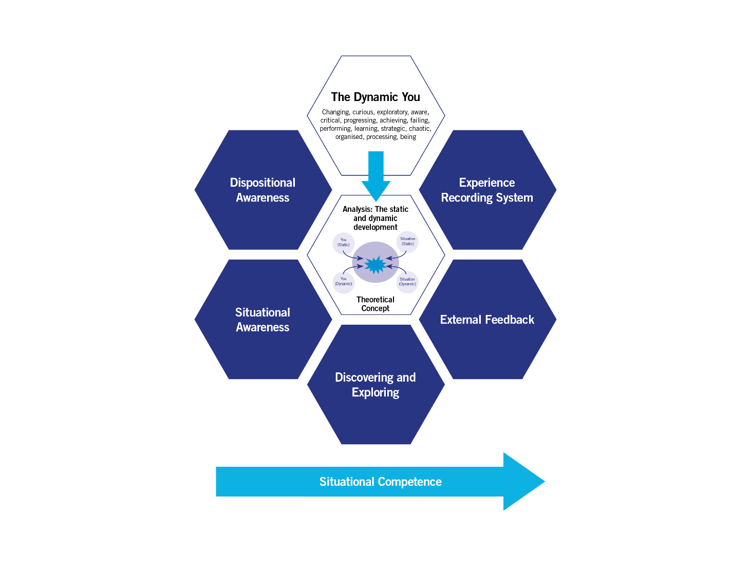
- The development of ‘Situational Competence’.

Figure E.1: A schematic of the Dynamic Development model.

The steps in this section are based on these three main aspects and we start in the centre of the schematic…

Step 1: How would you characterise presentation now?

Use the Game Board to consider the situational and dispositional components of oral presentation as you see them now. If you keep a copy of your initial views you can use the copy as a comparator part of your experience recording. Copies of the Game Board can be downloaded from
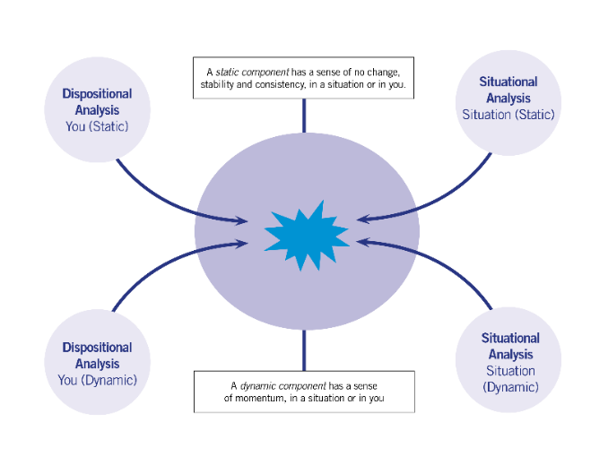
Figure E.2: The Game board

Figure E.3, provides an illustrative example for presentation constructed by Dr Tony Bromley. This may help you think about your own views. However, make sure that you do construct a diagram that reflects your view. It may well be very different from that of Dr Tony Bromley and that is important as it needs to be reflective of you!
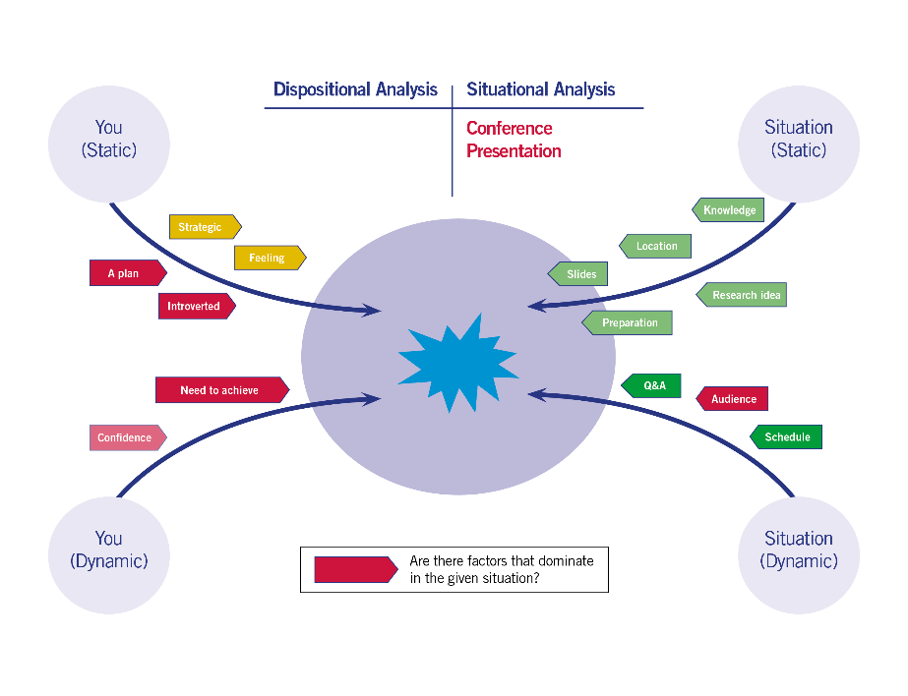

Figure E.3: A view of presentation (Dr Tony Bromley perspective)

Step 2: Some questions and thoughts for you
In constructing your view of presentation in step 1 did you find it easy? Do you feel you are very aware of the situation of oral presentation of research at a conference, situationally competent and satisfied that it isn’t an area you need to focus on for further development?

If not, we now need to look at the other five blue outer hexagons in the model to think about what would be the best next steps for you…

- you may need to gain further situational awareness by watching further presentations from colleagues, talking with colleagues about their views on presenting, taking a look online at conference presentations from others that are relevant to your field of work
- you may need to gain further dispositional awareness. Have you asked a colleague to watch a presentation you give and give you feedback (external feedback)? (You could give them one of the evaluation forms in this guide to support their feedback). Have you videoed yourself and watched it back (objectively).
- Have you compared your own progress (experience recording)? Video a presentation, look at it, make any changes and try again. You can do this personal in your own space and time or involve colleagues. Particularly if you are trying out a new presentation ahead of a conference. You will be making progress!
- External feedback
- Finally, how about looking at different presentation styles within your field or beyond. In public engagement or work with different audiences. All of this might feedback in to how you yourself present (discovering and exploring).

Step 3: So, next time I present I will…
You don’t have to fill this table! Make sure what you are proposing to do is realistic for your next presentation

Step 4: From situational competence to capital…

I’m sure you will now be building your situational competence in effective seminar and conference presentation (as confirmed by your evaluations and external feedback).

Now we can look at the last aspect of the dynamic development model and consider what you have built in terms of capital through building your situational competence. (The concept of ‘capital is explained further in Section C page 15 of the Dynamic Development Introductory Guide)

Table E 1 as an illustration, suggests possible capital you may have developed in an example for the situation of academic writing in the three areas ‘Expertise’, ‘Operational’ and ‘Social’. Table E 2 offers a blank space for you to record your own view for the situation of presentation using the writing example as a guide.

Expertise Capital |  | Operational Capital |  | Social Capital
Capital | Field(s) applicable | Capital | Field(s) applicable | Capital | Field(s) applicable
Writing and publishing an academic paper or article | The writing process is applicable to other types of writing. E.g. mapping out content, editing and reviewing, iterations of drafts. | Understanding how the publication process works in the academic context: peer review, journal ratings, open access publication etc. | Academic research  Academic publishing  Academic library roles | Meet journal editors and publishers | Academic research  Academic publishing  Copy editing

Table E.1. Suggests possible capital you may have developed in the situation of academic writing for the three areas ‘Expertise’, ‘Operational’ and ‘Social’.

Expertise Capital |  | Operational Capital |  | Social Capital
Capital | Field(s) applicable | Capital | Field(s) applicable | Capital | Field(s) applicable

Table E.2. A blank space for you to record your own view.

The resource is written for an undergraduate audience but the basic presentation ideas are well covered and generalisable https://library.leeds.ac.uk/info/1401/academic_skills/130/presentations (Accessed 02/07/19)
Extract from: Bromley, T., and Warnock, L., [2019] ‘The practice of developing researchers: the state of the art’ submitted for publication
Karen Adams (2004) Modelling success: enhancing international postgraduate research students' self‐efficacy for research seminar presentations, Higher Education Research & Development, 23:2, 115-130, DOI: 10.1080/0729436042000206618
Available at https://www.sdduonline.leeds.ac.uk/dynamic-development/downloads/ (accessed 2/7/19)

